 

NATIONAL PUBLIC SCHOOL
RAJAJINAGAR

COMPUTER SCIENCE PROJECT



FLIGHT RESERVATION

NAME : KRISHNA A KINNAL

CLASS : 12 B


CONTENTS

SL.NO | TOPIC | PAGE NO
1.  2.  3.  4.  5.  6.  7.  8.  9. | Acknowledgement  About C++  Introduction  Flow of control(flow chart)  Header files, functions  and classes used  Source Code  Output  Time Chart  Bibliography

ACKNOWLEDGEMENT

The sense of achievement after completing a project is incomplete without mentioning those who have helped in shaping it.
I would like to express my heartfelt gratitude to our beloved principal Ms. Sumitra Das and our vice principal Ms. Mini Jayant for giving me an opportunity to do this project.
I would also like to thank the computer science department and special thanks to my computer science teachers,Mrs. Vijaylaksmi for guiding me through this project and helping it attain its present form.
My project would not have been possible without the support of my parents and their valuable suggestions.
This Program is developed keping in mind the guidelines set up by the Central Board of Secondary Education and hence it suffices the requirements as prescribed by the board.

ABOUT C++
C++ is an object oriented programming language(OOP) created by Bjarne Stroustrup and released in 1985.It implements ‘data abstraction ’using a concept valled classes,along with other features to allow OOP.Parts of the C++ program are easily reusable and extensible;existing code is easily modifiable without actually having to change the code.C++ adds a concpt called ‘operator overloading’ not seen in the earlier OOP languages.
C++ maintains aspects of the C programming language,yet has features which simplify memory management.Additionally,some of the features of C++ allow low-level access to memory but also contain high level features.
C++ could be considered a superset of C.C uses structured programming concepts and techniques while C++ uses OOP and classes which focus on data.

INTRODUCTION
The following project represents a real life self service ticketing machine that is present at BIA(Bangalore International Airport) to book tickets for flights on the same day or the next day.
This program makes use of various concepts learnt in the past two years.The following concepts have been used:
- Classes(OOP concepts)
- Objects
- Data file handling
- Arrays
Through this program one can book a ticket and print it.One can also view a map of Bangalore to find out the route and timings of the Airport Shuttle Services to and from the airport .
Tickets can only be booked for a one way journey from Bangalore to any of these following destinations:
->New Delhi ->London ->Mumbai ->Paris ->Chennai ->Dubai ->Kolkata ->Hong Kong ->Hyderabad ->Singapore
There are two flights per day for domestic destinations but only one flight per day for international destinations.
As this is only a prototype , we have restricted the number of seats per flight to five only.

FLOW CHART

Main Menu
Shuttle timings
Flying to
Exit
Timings & Routes
No.of passengers
Enter date
Flight Details
Map of Bangalore
Enter destination
Domestic
International
Book a ticket
Passenger Names

Boarding Pass

HEADER FILES USED IN THE PROGRAM

#include<fstream.h>
#include<time.h>
#include<string.h>
#include<conio.h>
#include<stdio.h>
#include<stdlib.h>
#include<ctype.h>
#include<dos.h>
#include"plane.cpp"
#include"dest.cpp"
#include"shuttle.cpp"

CLASS USED IN THE PROGRAM

Class name: ticket

Data members:

int passengers; //to store number of passengers
date1 depart; //to store departure date
char destination[30]; //to store destination
char airline[30]; //to store name of the airline
char name[5][40]; //to store passenger name(s)
char boarding_time[10]; //to store boarding time
char depart_time[10]; //to store departure time
char travel_class; //to store flight class
char flight_code[10]; //to store flight code
int gate; //to store gate
float price; //to store price per passenger
float total; // to store total price

Member Functions:

ticket() //constructor to initialize no.of passengers to zero

int check(int nop); //to check if tickets available

void book_ticket(); //to book a ticket

FUNCTIONS USED IN THE PROGRAM

- void gen_ticket(ticket t)
Function to generate boarding pass

2. void welcome()
Function to generate main menu

3.void destinations()
Function to show the available destinations

4. float delay(float b)
Function to delay by ‘b’ seconds

5. void border()
Function to generate the border

6. void pic(int i)
Function to print the picture of a plane

7. plane()
Function to call border(),pic(int i)

8. void shuttle()
Function to show map of Bangalore,timings and routes of the
shuttle service

SOURCE CODE

* dest.cpp

#include<iostream.h>
void destinations()
{
clrscr();
gotoxy(30,7);
cout<<"Domestic destinations";
gotoxy(33,9);
cout<<"1. New Delhi";
gotoxy(33,10);
cout<<"2. Mumbai";
gotoxy(33,11);
cout<<"3. Chennai";
gotoxy(33,12);
cout<<"4. Kolkatta";
gotoxy(33,13);
cout<<"5. Hyderabad";
gotoxy(27,16);
cout<<"Press any key to proceed...";
getch();
clrscr();
gotoxy(27,7);
cout<<"International Destinations";
gotoxy(33,9);
cout<<"1. London";
gotoxy(33,10);
cout<<"2. Paris";
gotoxy(33,11);
cout<<"3. Dubai";
gotoxy(33,12);
cout<<"4. Singapore ";
gotoxy(33,13);
cout<<"5. Hong Kong";
gotoxy(27,16);
cout<<"Press any key to continue ";
getch();
clrscr();
}

* shuttle.cpp

#include<iostream.h>
void shuttle()
{

clrscr();
gotoxy(50,5);
cout<<"MAP OF BANGALORE CITY";
gotoxy(55,6);
cout<<"NOT TO SCALE";
gotoxy(50,9);
cout<<"Press a key to continue ";
gotoxy(35,3);
cout<<" BIAL ";
gotoxy(33,3);
cout<<"..";
for(int i=3;i<=23;i++)
{
if(i==7 || i==13 || i==23)
{gotoxy(33,i); cout<<"@";}
else
{gotoxy(33,i); cout<<".";}
}
gotoxy(8,11); cout<<"..........................";
gotoxy(8,12); cout<<".";
gotoxy(8,13); cout<<".";
gotoxy(8,14); cout<<".";
gotoxy(8,15); cout<<".";
gotoxy(8,16); cout<<"@";
gotoxy(33,15); cout<<"...................@";
gotoxy(53,15); cout<<"...................@";
gotoxy(27,17); cout<<"......";
gotoxy(26,18); cout<<".";
gotoxy(25,19); cout<<".";
gotoxy(24,20); cout<<".";
gotoxy(23,21); cout<<".";
gotoxy(22,22); cout<<".";
gotoxy(18,22); cout<<"@....";
gotoxy(5,21); cout<<"Basavanagudi (8)";
gotoxy(33,17); cout<<"......";
gotoxy(39,18); cout<<".";
gotoxy(40,19); cout<<".";
gotoxy(41,20); cout<<".";
gotoxy(42,21); cout<<".";
gotoxy(43,22); cout<<"............@";
gotoxy(46,21); cout<<"Electronics City (7)";
gotoxy(65,16); cout<<"Whitefield (6)";
gotoxy(47,16); cout<<"M G Road (4)";
gotoxy(4,17); cout<<"Mysore Road (3)";
gotoxy(22,7); cout<<"Hebbal (1)";
gotoxy(35,13); cout<<"Majestic (2)";
gotoxy(24,24); cout<<"Jayanagar 4th Block (5)";
gotoxy(74,9);
getch();
clrscr();
cout<<endl<<endl<<"________________________________________________________________________________"<<endl;
gotoxy(5,4); cout<<"Start";
gotoxy(25,4); cout<<"End";
gotoxy(30,4); cout<<"Bus Number";
gotoxy(45,4); cout<<"First Departure";
gotoxy(65,4); cout<<"Frequency"<<endl;
cout<<"________________________________________________________________________________"<<endl;
gotoxy(5,6); cout<<"Hebbal"; gotoxy(25,6); cout<<"BIA"; gotoxy(32,6); cout<<"BIA 1"; gotoxy(45,6); cout<<"4:00 AM"; gotoxy(65,6); cout<<"1 hour";
gotoxy(5,8); cout<<"Majestic"; gotoxy(25,8); cout<<"BIA"; gotoxy(32,8); cout<<"BIA 2"; gotoxy(45,8); cout<<"4:30 AM"; gotoxy(65,8); cout<<"1 hour";
gotoxy(5,10); cout<<"Mysore Road"; gotoxy(25,10); cout<<"BIA"; gotoxy(32,10); cout<<"BIA 3"; gotoxy(45,10); cout<<"5:00 AM"; gotoxy(65,10); cout<<"0.5 hours";
gotoxy(5,12); cout<<"M G Road"; gotoxy(25,12); cout<<"BIA"; gotoxy(32,12); cout<<"BIA 4"; gotoxy(45,12); cout<<"5:00 AM"; gotoxy(65,12); cout<<"1 hour";
gotoxy(5,14); cout<<"Jayangar 4th Block"; gotoxy(25,14); cout<<"BIA"; gotoxy(32,14); cout<<"BIA 5"; gotoxy(45,14); cout<<"5:00 AM"; gotoxy(65,14); cout<<"1.5 hours";
gotoxy(5,16); cout<<"Whitefield"; gotoxy(25,16); cout<<"BIA"; gotoxy(32,16); cout<<"BIA 6"; gotoxy(45,16); cout<<"5:00 AM"; gotoxy(65,16); cout<<"1.5 hours";
gotoxy(5,18); cout<<"Electonics City"; gotoxy(25,18); cout<<"BIA"; gotoxy(32,18); cout<<"BIA 7"; gotoxy(45,18); cout<<"6:00 AM"; gotoxy(65,18); cout<<"2 hours";
gotoxy(5,20); cout<<"Basavanagudi"; gotoxy(25,20); cout<<"BIA"; gotoxy(32,20); cout<<"BIA 8"; gotoxy(45,20); cout<<"5:00 AM"; gotoxy(65,20); cout<<"1.5 hours"<<endl;;
cout<<"________________________________________________________________________________"<<endl;
gotoxy(30,23); cout<<"Press a key to continue ";
getch();
clrscr();
}

* plane.cpp

#include<iostream.h>
#include<conio.h>
#include<time.h>

float delay1(float b)
{
float sec;
clock_t start,end;
start=clock();
a:

end=clock();
sec=(end-start)/CLK_TCK;
if(sec>b)
return sec;
goto a;
}
void border()
{
for(int i=2;i<=79;i++)
{
gotoxy(i,1);cout<<"-";
gotoxy(i,25);cout<<"-";
}
for(int j=2;j<25;j++)
{
gotoxy(2,j);cout<<"|";
gotoxy(79,j);cout<<"|";
}

}
void pic(int i)
{
gotoxy(i,9); cout<<"|---\\ |---\\ "<<endl;
gotoxy(i,10);cout<<"| \\ | \\ "<<endl;
gotoxy(i,11);cout<<"----------------------------\\"<<endl;
gotoxy(i,12);cout<<"| [] [] [] [] [] |____\\ "<<endl;
gotoxy(i,13);cout<<"-------------------------------"<<endl;
gotoxy(i,14);cout<<" | / "<<endl;
gotoxy(i,15);cout<<" |---/ "<<endl;
}
plane()
{
for(int i=1;i<=45;i++)
{
gotoxy(25,3);cout<<" BANGALORE INTERNATIONAL AIRPORT \n";
pic(i);
border();
delay1(0.001);
clrscr();
}

}

* bial.cpp

#include<fstream.h>
#include<time.h>
#include<string.h>
#include<conio.h>
#include<stdio.h>
#include<stdlib.h>
#include<ctype.h>
#include<dos.h>
#include"plane.cpp"
#include"dest.cpp"
#include"shuttle.cpp"

int a,i;

int check_count; //to check if both flights are booked for that day

int countnd1=0,countnd2=0,countnd3=0,countnd4=0; //to keep count of no.of passengers in each flight
int countmu1=0,countmu2=0,countmu3=0,countmu4=0;
int countcn1=0,countcn2=0,countcn3=0,countcn4=0;
int countko1=0,countko2=0,countko3=0,countko4=0;
int counthy1=0,counthy2=0,counthy3=0,counthy4=0;
int countlo1=0,countlo2=0;
int countpa1=0,countpa2=0;
int countdu1=0,countdu2=0;
int countsi1=0,countsi2=0;
int counthk1=0,counthk2=0;

int choice;

void welcome();

float delay(float b)
{
float sec;
clock_t start,end;
start=clock();
a:
end=clock();
sec=(end-start)/CLK_TCK;
if(sec>b)
return sec;
goto a;
}
struct date1
{
int dd,mm,yy;
};

class ticket
{
public:
int passengers;
date1 depart;
char destination[30];
char airline[30];
char name[5][40];
char boarding_time[10];
char depart_time[10];
char travel_class;
char flight_code[10];
int gate;
unsigned long int price, total;
ticket()
{
passengers=0;
strcpy(destination," ");
strcpy(airline," ");
strcpy(name[0]," ");
strcpy(name[1]," ");
strcpy(name[2]," ");
strcpy(name[3]," ");
strcpy(name[4]," ");
strcpy(boarding_time," ");
strcpy(depart_time," ");
strcpy(flight_code," ");
travel_class='\0';
gate=0;
price=0;
total=0;
depart.dd=0;
depart.mm=0;
depart.yy=0;

}

int check(int nop)
{
if(nop<=5)
return 1;
else
return 0;
}
void book_ticket();
};//end of class

ticket ABC;

void gen_ticket(ticket t) //function to generate boarding pass
{
for(int i=0;i<3;i++)
{
clrscr();
gotoxy(15,10);
cout<<"Please Wait While your Boarding Pass is Being Processed ";
gotoxy(35,12);
cout<<"Loading .";
delay(0.3);
clrscr();
gotoxy(15,10);
cout<<"Please Wait While your Boarding Pass is Being Processed ";
gotoxy(35,12);
cout<<"Loading ..";
delay(0.3);
clrscr();
gotoxy(15,10);
cout<<"Please Wait While your Boarding Pass is Being Processed ";
gotoxy(35,12);
cout<<"Loading ...";
delay(0.3);
clrscr();
}
gotoxy(2,1);
for(i=1;i<=78;i++)
cout<<char(0);
for(i=2;i<=18;i++)
{
gotoxy(2,i); cout<<char(0);
gotoxy(79,i); cout<<char(0)<<endl;
}
gotoxy(2,19);
for(i=1;i<=78;i++)
cout<<char(0);
gotoxy(33,2);
cout<<"BOARDING PASS";
gotoxy(33,18);
cout<<"Airline - " <<t.airline;
gotoxy(15,4);
cout<<"Name(s)";
int j=5;
for(i=0;i<t.passengers;i++,j++)
{
gotoxy(15,j);
cout<<"-> "<<t.name[i];
}
gotoxy(15,11);
cout<<"From - ";
cout<<"Bengaluru";
gotoxy(15,12);
cout<<"To - ";
cout<<t.destination;
gotoxy(45,4);
cout<<"Flight No. - ";
cout<<t.flight_code;
gotoxy(45,6);
cout<<"Class - ";
cout<<t.travel_class;
gotoxy(45,8);
cout<<"Date - ";
cout<<t.depart.dd<<"/"<<t.depart.mm<<"/"<<t.depart.yy;
gotoxy(45,9);
cout<<"Boarding Time - ";
cout<<t.boarding_time;
gotoxy(45,11);
cout<<"Gate - ";
cout<<t.gate;
gotoxy(45,13);
cout<<"Departure Time - ";
cout<<t.depart_time;
gotoxy(21,15);
cout<<"Total price = "<<t.price<<" X "<<t.passengers<<" = Rs. "<<t.total;
gotoxy(28,22);
cout<<"Please print your boarding pass ";
gotoxy(22,23);
cout<<"Press any key to go back to the main menu ";
getch();
clrscr();
}
void ticket::book_ticket()
{
ticket t;
clrscr();
D:
gotoxy(25,1);
cout<<"Welcome to the Ticket Center !!!";
gotoxy(10,3);
cout<<"PLEASE NOTE :TICKETS CAN BE BOOKED FOR TODAY AND TOMORROW ONLY";
gotoxy(7,6);
for(i=1;i<=65;i++)
cout<<char(0);
for(i=7;i<=22;i++)
{
gotoxy(7,i); cout<<char(0);
gotoxy(71,i); cout<<char(0);
}
gotoxy(7,23);
for(i=1;i<=65;i++)
cout<<char(0);
gotoxy(21,8);
cout<<"Domestic";
gotoxy(20,10);
cout<<"New Delhi";
gotoxy(20,11);
cout<<"Mumbai";
gotoxy(20,12);
cout<<"Chennai";
gotoxy(20,13);
cout<<"Kolkata";
gotoxy(20,14);
cout<<"Hyderabad";
gotoxy(43,8);
cout<<"International";
gotoxy(46,10);
cout<<"London";
gotoxy(46,11);
cout<<"Paris";
gotoxy(46,12);
cout<<"Dubai";
gotoxy(46,13);
cout<<"Singapore ";
gotoxy(46,14);
cout<<"Hong Kong";
gotoxy(10,16);
cout<<"-> Enter your destination - ";
gotoxy(38,16);
gets(t.destination);
if ((strcmpi(t.destination,"New Delhi")!=0) && (strcmpi(t.destination,"Mumbai")!=0) && (strcmpi(t.destination,"Chennai")!=0) && (strcmpi(t.destination,"Kolkata")!=0) && (strcmpi(t.destination,"Hyderabad")!=0) && (strcmpi(t.destination,"London")!=0) && (strcmpi(t.destination,"Paris")!=0) && (strcmpi(t.destination,"Dubai")!=0) && (strcmpi(t.destination,"Singapore")!=0) && (strcmpi(t.destination,"Hong Kong")!=0))
{
gotoxy(19,19);
cout<<"Destination Not Available /Check spelling ";
gotoxy(31,20);
cout<<"Please Re- Enter ";
getch();
clrscr();
goto D;
}
E:
gotoxy(10,18);
cout<<"-> Enter the number of passengers traveling - ";
cin>>t.passengers;
if(t.passengers > 5 || t.passengers<=0)
{
gotoxy(13,21);
cout<<"Flight capacity is 5/Invalid Entry,Please Re-Enter ";
getch();
gotoxy(13,21);
cout<<" ";
gotoxy(10,18);
cout<<" ";
goto E;
}
gotoxy(23,21);
cout<<"Press any key to continue ...";
getch();
clrscr();
B:
clrscr();
gotoxy(7,6);
for(i=1;i<=65;i++)
cout<<char(0);
for(i=7;i<=20;i++)
{
gotoxy(7,i); cout<<char(0);
gotoxy(71,i); cout<<char(0);
}
gotoxy(7,21);
for(i=1;i<=65;i++)
cout<<char(0);
gotoxy(17,10);
cout<<"-> Enter the date of departure - ";
gotoxy(25,11);
cout<<"(dd mm yyyy)";
gotoxy(50,10);
cin>>t.depart.dd>>t.depart.mm>>t.depart.yy;

// DATE CHECK
struct date d;
getdate(&d);

if(((int)(d.da_day)==31 &&((int)(d.da_day) != 31 && (int)(d.da_day) != 1) && ((int)d.da_mon)!=12) || t.depart.mm < ((int)d.da_mon))
{
gotoxy(15,15);
cout<<"* Tickets can be booked only for today and tomorrow\n";
gotoxy(9,16);
cout<<"* Check if the date entered is in the correct format as shown ";
gotoxy(33,17);
cout<<"Please re-enter";
getch();
goto B;
}
else if((int)(d.da_day)==30 &&((int)(d.da_day) != 30 && (int)(d.da_day) != 1) || t.depart.mm < ((int)d.da_mon))
{
gotoxy(15,15);
cout<<"* Tickets can be booked only for today and tomorrow\n";
gotoxy(9,16);
cout<<"* Check if the date entered is in the correct format as shown ";
gotoxy(33,17);
cout<<"Please re-enter";
getch();
goto B;
}
else if((int)(d.da_day)==28 &&((int)(d.da_day) != 28 && (int)(d.da_day) != 1) || t.depart.mm < ((int)d.da_mon))
{
gotoxy(15,15);
cout<<"* Tickets can be booked only for today and tomorrow\n";
gotoxy(9,16);
cout<<"* Check if the date entered is in the correct format as shown ";
gotoxy(33,17);
cout<<"Please re-enter";
getch();
goto B;
}
else if((int)(d.da_day)==31 &&((int)(d.da_day) != 31 && (int)(d.da_day) != 1) || t.depart.mm > ((int)d.da_mon))
{
gotoxy(15,15);
cout<<"* Tickets can be booked only for today and tomorrow\n";
gotoxy(9,16);
cout<<"* Check if the date entered is in the correct format as shown ";
gotoxy(33,17);
cout<<"Please re-enter";
getch();
goto B;
}
if(t.depart.dd < (int)(d.da_day) || t.depart.mm < (int)(d.da_mon) || t.depart.yy < d.da_year )
{
gotoxy(15,15);
cout<<"* Tickets can be booked only for today and tomorrow\n";
gotoxy(9,16);
cout<<"* Check if the date entered is in the correct format as shown ";
gotoxy(33,17);
cout<<"Please re-enter";
getch();
goto B;
}
else if(t.depart.dd > ((int)(d.da_day) + 1) || t.depart.mm > (int)(d.da_mon) + 1 || t.depart.yy > (d.da_year + 1) )
{
gotoxy(15,15);
cout<<"* Tickets can be booked only for today and tomorrow\n";
gotoxy(9,16);
cout<<"* Check if the date entered is in the correct format as shown ";
gotoxy(33,17);
cout<<"Please re-enter";
getch();
goto B;
}

gotoxy(27,16);
cout<<"Press any key to continue ";
getch();
clrscr();

// END OF DATE CHECK

for(int i=0;i<3;i++)
{
gotoxy(18,10);
cout<<"Please wait while flights are being processed ";
gotoxy(35,12);
cout<<"Loading .";
delay(0.3);
clrscr();
gotoxy(18,10);
cout<<"Please wait while flights are being processed ";
gotoxy(35,12);
cout<<"Loading ..";
delay(0.3);
clrscr();
gotoxy(18,10);
cout<<"Please wait while flights are being processed ";
gotoxy(35,12);
cout<<"Loading ...";
delay(0.3);
clrscr();
}
//**************************************** NEW DELHI ***********************************************************
if(strcmpi(t.destination,"New Delhi")==0)
{
Cnd:
gotoxy(30,2);
cout<<" Choose your Flight ...";
cout<<endl<<endl<<endl<<"_______________________________________________________________________________";
gotoxy(1,6);
cout<<"S No.";
gotoxy(10,6);
cout<<"Airline";
gotoxy(25,6);
cout<<"Class";
gotoxy(40,6);
cout<<"Departure";
gotoxy(55,6);
cout<<"Arrival";
gotoxy(65,6);
cout<<"Price (in Rs.)"<<endl;
cout<<"_______________________________________________________________________________";
gotoxy(1,8);
cout<<"1.";
gotoxy(10,8);
cout<<"IndiGo";
gotoxy(25,8);
cout<<"Economy";
gotoxy(40,8);
cout<<"6:00 AM";
gotoxy(55,8);
cout<<"8:45 AM";
gotoxy(68,8);
cout<<"8,397";
gotoxy(1,9);
cout<<"2.";
gotoxy(10,9);
cout<<"Air India";
gotoxy(25,9);
cout<<"Business";
gotoxy(40,9);
cout<<"10:30 AM";
gotoxy(55,9);
cout<<"1:05 PM";
gotoxy(68,9);
cout<<"8,691";
gotoxy(25,17);
cout<<"Choose a flight to proceed - ";
cin>>choice;

for(int i=0;i<3;i++)
{
clrscr();
gotoxy(18,10);
cout<<"Please wait while tickets are being processed ";
gotoxy(35,12);
cout<<"Loading .";
delay(0.3);
clrscr();
gotoxy(18,10);
cout<<"Please wait while tickets are being processed ";
gotoxy(35,12);
cout<<"Loading ..";
delay(0.3);
clrscr();
gotoxy(18,10);
cout<<"Please wait while tickets are being processed ";
gotoxy(35,12);
cout<<"Loading ...";
delay(0.3);
clrscr();
}
if((int)d.da_day==t.depart.dd && choice==1) //if departure date is today and flight chosen is 1
{
fstream f1("NewDelhi-1a.dat",ios::out|ios::in|ios::binary);
if(check(countnd1+t.passengers)==1) //to check flight availability
{
clrscr();
int j;
gotoxy(8,3);
for(i=1;i<=64;i++)
cout<<char(0);
for(i=4;i<=17;i++)
{
gotoxy(8,i); cout<<char(0);
gotoxy(71,i); cout<<char(0);
}
gotoxy(8,i);
for(i=1;i<=64;i++)
cout<<char(0);
gotoxy(20,5);
cout<<"Enter the Details of the Passengers";
for(i=0,j=8;i<t.passengers;i++,j++)
{
gotoxy(17,j);
cout<<"Enter name of passenger "<<(i+1)<<" - ";
gets(t.name[i]);
strcpy(t.boarding_time,"5:30 AM");
strcpy(t.depart_time,"6:30 AM");
strcpy(t.flight_code,"6E 334");
strcpy(t.airline,"IndiGo");
t.gate=1;
t.travel_class='E';
t.price=8397;
t.total=t.price*t.passengers;
f1.write((char *)&t,sizeof(t));
countnd1++;
}
gotoxy(23,15);
cout<<"Press any key to continue ... ";
getch();
clrscr();
gen_ticket(t);
clrscr();
f1.close();
}

else
{
gotoxy(22,11);cout<<"Sorry, This Flight is Completely Booked";
gotoxy(27,12);cout<<"Please try the other flight ";
check_count++;
if(check_count==2) //if both flights are booked
{
gotoxy(17,11); cout<<"All flights to New Delhi today are completely booked";
gotoxy(21,12); cout<<"Press any key to go back to the main menu ";
getch();
clrscr();
welcome();
}
getchar();
clrscr();
goto Cnd;
}
}
else if((int)d.da_day==t.depart.dd && choice==2) //if departure date is today and flight chosen is 2
{
clrscr();
fstream f2("New_Delhi-1b.dat",ios::out|ios::in|ios::binary);
if(check(countnd2+t.passengers)==1)
{
int j;
gotoxy(8,3);
for(i=1;i<=64;i++)
cout<<char(0);
for(i=4;i<=17;i++)
{
gotoxy(8,i); cout<<char(0);
gotoxy(71,i); cout<<char(0);
}
gotoxy(8,i);
for(i=1;i<=64;i++)
cout<<char(0);
gotoxy(20,5);
cout<<"Enter the Details of the Passengers";
for(i=0,j=8;i<t.passengers;i++,j++)
{
gotoxy(17,j);
cout<<"Enter name of passenger "<<(i+1)<<" - ";
gets(t.name[i]);
strcpy(t.boarding_time,"10:00 AM");
strcpy(t.depart_time,"10:30 AM");
strcpy(t.flight_code,"AI 123");
strcpy(t.airline,"Air India");
t.gate=15;
t.travel_class='B';
t.price=8691;
t.total=t.price*t.passengers;
f2.write((char *)&t,sizeof(t));
countnd2++;
}
gotoxy(23,15);
cout<<"Press any key to continue ... ";
getch();
clrscr();
gen_ticket(t);
clrscr();
f2.close();
}

else
{
gotoxy(22,11);cout<<"Sorry, This Flight is Completely Booked";
gotoxy(27,12);cout<<"Please try the other flight ";
check_count++;
if(check_count==2) //
{
gotoxy(17,11); cout<<"All flights to New Delhi today are completely booked";
gotoxy(21,12); cout<<"Press any key to go back to the main menu ";
getch();
clrscr();
welcome();
}
getchar();
clrscr();
goto Cnd;
}
}

else if(((int)d.da_day)+1==t.depart.dd && choice==1) //if departure date is the next day and flight chosen is 1
{
fstream f3("New_Delhi-2a.dat",ios::out|ios::in|ios::binary);

if(check(countnd3+t.passengers)==1)
{
clrscr();
int j;
gotoxy(8,3);
for(i=1;i<=64;i++)
cout<<char(0);
for(i=4;i<=17;i++)
{
gotoxy(8,i); cout<<char(0);
gotoxy(71,i); cout<<char(0);
}
gotoxy(8,i);
for(i=1;i<=64;i++)
cout<<char(0);
gotoxy(20,5);
cout<<"Enter the Details of the Passengers";
for(i=0,j=8;i<t.passengers;i++,j++)
{
gotoxy(17,j);
cout<<"Enter name of passenger "<<(i+1)<<" - ";
gets(t.name[i]);
strcpy(t.boarding_time,"5:30 AM");
strcpy(t.depart_time,"6:00 AM");
strcpy(t.flight_code,"6E 334");
strcpy(t.airline,"IndiGo");
t.gate=1;
t.travel_class='E';
t.price=8397;
t.total=t.price*t.passengers;
f3.write((char *)&t,sizeof(t));
countnd3++;
}
gotoxy(23,15);
cout<<"Press any key to continue ... ";
getch();
clrscr();
gen_ticket(t);
clrscr();
f3.close();
}

else
{
gotoxy(22,11);cout<<"Sorry, This Flight is Completely Booked";
gotoxy(27,12);cout<<"Please try the other flight ";
check_count++;
if(check_count==2)
{
gotoxy(17,11); cout<<"All flights to New Delhi today are completely booked";
gotoxy(21,12); cout<<"Press any key to go back to the main menu ";
getch();
clrscr();
welcome();
}
getchar();
clrscr();
goto Cnd;
}
}
else if((int)d.da_day+1==t.depart.dd && choice==2) //if departure date is the next day and flight chosen is 2
{
clrscr();
fstream f4("New_Delhi-2b.dat",ios::out|ios::in|ios::binary);
if(check(countnd4+t.passengers)==1)
{
int j;
gotoxy(8,3);
for(i=1;i<=64;i++)
cout<<char(0);
for(i=4;i<=17;i++)
{
gotoxy(8,i); cout<<char(0);
gotoxy(71,i); cout<<char(0);
}
gotoxy(8,i);
for(i=1;i<=64;i++)
cout<<char(0);
gotoxy(20,5);
cout<<"Enter the Details of the Passengers";
for(i=0,j=8;i<t.passengers;i++,j++)
{
gotoxy(17,j);
cout<<"Enter name of passenger "<<(i+1)<<" - ";
gets(t.name[i]);
strcpy(t.boarding_time,"10:00 AM");
strcpy(t.depart_time,"10:30 AM");
strcpy(t.flight_code,"AI 123");
strcpy(t.airline,"Air India");
t.gate=15;
t.travel_class='B';
t.price=8691;
t.total=t.price*t.passengers;
f4.write((char *)&t,sizeof(t));
countnd4++;
}

gotoxy(23,15);
cout<<"Press any key to continue ... ";
getch();
clrscr();
gen_ticket(t);
clrscr();
f4.close();
}

else
{
gotoxy(22,11);cout<<"Sorry, This Flight is Completely Booked";
gotoxy(27,12);cout<<"Please try the other flight ";
check_count++;
if(check_count==2)
{
gotoxy(17,11); cout<<"All flights to New Delhi today are completely booked";
gotoxy(21,12); cout<<"Press any key to go back to the main menu ";
getch();
clrscr();
welcome();
}
getchar();
clrscr();
goto Cnd;
}
}
}
//*************************************** MUMBAI *********************************************************
else if(strcmpi(t.destination,"Mumbai")==0)
{
Cm:
gotoxy(30,2);
cout<<" Choose your Flight ...";
cout<<endl<<endl<<endl<<"_______________________________________________________________________________";
gotoxy(1,6);
cout<<"S No.";
gotoxy(10,6);
cout<<"Airline";
gotoxy(25,6);
cout<<"Class";
gotoxy(40,6);
cout<<"Departure";
gotoxy(55,6);
cout<<"Arrival";
gotoxy(65,6);
cout<<"Price (in Rs.)"<<endl;
cout<<"_______________________________________________________________________________";
gotoxy(1,8);
cout<<"1.";
gotoxy(10,8);
cout<<"Go Air ";
gotoxy(25,8);
cout<<"Economy";
gotoxy(40,8);
cout<<"5:55 AM";
gotoxy(55,8);
cout<<"7:25 AM";
gotoxy(68,8);
cout<<"5,512";
gotoxy(1,9);
cout<<"2.";
gotoxy(10,9);
cout<<"Jet Airways";
gotoxy(25,9);
cout<<"Business";
gotoxy(40,9);
cout<<"11:25 AM";
gotoxy(55,9);
cout<<"12:55 PM";
gotoxy(68,9);
cout<<"5,565";
gotoxy(25,17);
cout<<"Choose a flight to proceed - ";
cin>>choice;

for(int i=0;i<3;i++)
{
clrscr();
gotoxy(18,10);
cout<<"Please wait while tickets are being processed ";
gotoxy(35,12);
cout<<"Loading .";
delay(0.3);
clrscr();
gotoxy(18,10);
cout<<"Please wait while tickets are being processed ";
gotoxy(35,12);
cout<<"Loading ..";
delay(0.3);
clrscr();
gotoxy(18,10);
cout<<"Please wait while tickets are being processed ";
gotoxy(35,12);
cout<<"Loading ...";
delay(0.3);
clrscr();
}
if((int)d.da_day==t.depart.dd && choice==1)
{
fstream f1("Mumbai-1a.dat",ios::out|ios::in|ios::binary);
if(check(countmu1+t.passengers)==1)
{
clrscr();
int j;
gotoxy(8,3);
for(i=1;i<=64;i++)
cout<<char(0);
for(i=4;i<=17;i++)
{
gotoxy(8,i); cout<<char(0);
gotoxy(71,i); cout<<char(0);
}
gotoxy(8,i);
for(i=1;i<=64;i++)
cout<<char(0);
gotoxy(20,5);
cout<<"Enter the Details of the Passengers";
for(i=0,j=8;i<t.passengers;i++,j++)
{
gotoxy(17,j);
cout<<"Enter name of passenger "<<(i+1)<<" - ";
gets(t.name[i]);
strcpy(t.boarding_time,"5:25 AM");
strcpy(t.depart_time,"5:55 AM");
strcpy(t.flight_code,"G8 512");
strcpy(t.airline,"Go Air");
t.gate=5;
t.travel_class='E';
t.price=5512;
t.total=t.price*t.passengers;
f1.write((char *)&t,sizeof(t));
countmu1++;
}

gotoxy(23,15);
cout<<"Press any key to continue ... ";
getch();
clrscr();
gen_ticket(t);
clrscr();
f1.close();
}

else
{
clrscr();
gotoxy(22,11);cout<<"Sorry, This Flight is Completely Booked";
gotoxy(27,12);cout<<"Please try the other flight ";
check_count++;
if(check_count==2)
{
gotoxy(17,11); cout<<"All flights to Mumbai today are completely booked";
gotoxy(21,12); cout<<"Press any key to go back to the main menu ";
getch();
clrscr();
welcome();
}
getchar();
clrscr();
goto Cm;
}
}
else if((int)d.da_day==t.depart.dd && choice==2)
{
clrscr();
fstream f2("Mumbai-1b.dat",ios::out|ios::in|ios::binary);
if(check(countmu2+t.passengers)==1)
{
int j;
gotoxy(8,3);
for(i=1;i<=64;i++)
cout<<char(0);
for(i=4;i<=17;i++)
{
gotoxy(8,i); cout<<char(0);
gotoxy(71,i); cout<<char(0);
}
gotoxy(8,i);
for(i=1;i<=64;i++)
cout<<char(0);
gotoxy(20,5);
cout<<"Enter the Details of the Passengers";
for(i=0,j=8;i<t.passengers;i++,j++)
{
gotoxy(17,j);
cout<<"Enter name of passenger "<<(i+1)<<" - ";
gets(t.name[i]);
strcpy(t.boarding_time,"10:55 AM");
strcpy(t.depart_time,"11:25 AM");
strcpy(t.flight_code,"9W 123");
strcpy(t.airline,"Jet Airways");
t.gate=15;
t.travel_class='B';
t.price=5565;
t.total=t.price*t.passengers;
f2.write((char *)&t,sizeof(t));
countmu2++;
}
gotoxy(23,15);
cout<<"Press any key to continue ... ";
getch();
clrscr();
gen_ticket(t);
clrscr();
f2.close();
}

else
{
gotoxy(22,11);cout<<"Sorry, This Flight is Completely Booked";
gotoxy(27,12);cout<<"Please try the other flight ";
check_count++;
if(check_count==2)
{
gotoxy(17,11); cout<<"All flights to Mumbai today are completely booked";
gotoxy(21,12); cout<<"Press any key to go back to the main menu ";
getch();
clrscr();
welcome();
}
getchar();
clrscr();
goto Cm;
}
}
else if(((int)d.da_day)+1==t.depart.dd && choice==1)
{
fstream f3("Mumbai-2a.dat",ios::out|ios::in|ios::binary);

if(check(countmu3+t.passengers)==1)
{
clrscr();
int j;
gotoxy(8,3);
for(i=1;i<=64;i++)
cout<<char(0);
for(i=4;i<=17;i++)
{
gotoxy(8,i); cout<<char(0);
gotoxy(71,i); cout<<char(0);
}
gotoxy(8,i);
for(i=1;i<=64;i++)
cout<<char(0);
gotoxy(20,5);
cout<<"Enter the Details of the Passengers";
for(i=0,j=8;i<t.passengers;i++,j++)
{
gotoxy(17,j);
cout<<"Enter Name of Passenger "<<(i+1)<<" - ";
gets(t.name[i]);
strcpy(t.boarding_time,"5:25 AM");
strcpy(t.depart_time,"5:55 AM");
strcpy(t.flight_code,"G8 512");
strcpy(t.airline,"Go Air");
t.gate=5;
t.travel_class='E';
t.price=5512;
t.total=t.price*t.passengers;
f3.write((char *)&t,sizeof(t));
countmu3++;
}

gotoxy(23,15);
cout<<"Press any key to continue ... ";
getch();
clrscr();
gen_ticket(t);
clrscr();
f3.close();
}

else
{
gotoxy(22,11);cout<<"Sorry, This Flight is Completely Booked";
gotoxy(27,12);cout<<"Please try the other flight ";
check_count++;
if(check_count==2)
{
gotoxy(17,11); cout<<"All flights to Mumbai today are completely booked";
gotoxy(21,12); cout<<"Press any key to go back to the main menu ";
getch();
clrscr();
welcome();
}
getchar();
clrscr();
goto Cm;
}
}
//*****************************************************************************************************************
else if((int)d.da_day+1==t.depart.dd && choice==2)
{
clrscr();
fstream f4("Mumbai-2b.dat",ios::out|ios::in|ios::binary);
if(check(countmu4+t.passengers)==1)
{
clrscr();
int j;
gotoxy(8,3);
for(i=1;i<=64;i++)
cout<<char(0);
for(i=4;i<=17;i++)
{
gotoxy(8,i); cout<<char(0);
gotoxy(71,i); cout<<char(0);
}
gotoxy(8,i);
for(i=1;i<=64;i++)
cout<<char(0);
gotoxy(20,5);
cout<<"Enter the Details of the Passengers";
for(i=0,j=8;i<t.passengers;i++,j++)
{
gotoxy(17,j);
cout<<"Enter name of passenger "<<(i+1)<<" - ";
gets(t.name[i]);
strcpy(t.boarding_time,"10:55 AM");
strcpy(t.depart_time,"11:25 AM");
strcpy(t.flight_code,"9W 123");
strcpy(t.airline,"Jet Airways");
t.gate=15;
t.travel_class='B';
t.price=5565;
t.total=t.price*t.passengers;
f4.write((char *)&t,sizeof(t));
countmu4++;
}

gotoxy(23,15);
cout<<"Press any key to continue ... ";
getch();
clrscr();
gen_ticket(t);
clrscr();
f4.close();
}

else
{
gotoxy(22,11);cout<<"Sorry, This Flight is Completely Booked";
gotoxy(27,12);cout<<"Please try the other flight ";
check_count++;
if(check_count==2)
{
gotoxy(17,11); cout<<"All flights to Mumbai today are completely booked";
gotoxy(21,12); cout<<"Press any key to go back to the main menu ";
getch();
clrscr();
welcome();
}
getchar();
clrscr();
goto Cm;
}
}
}
//*************************************** CHENNAI *******************************************************************
if(strcmpi(t.destination,"Chennai")==0)
{
Ccn:
gotoxy(30,2);
cout<<" Choose your Flight ...";
cout<<endl<<endl<<endl<<"_______________________________________________________________________________";
gotoxy(1,6);
cout<<"S No.";
gotoxy(10,6);
cout<<"Airline";
gotoxy(25,6);
cout<<"Class";
gotoxy(40,6);
cout<<"Departure";
gotoxy(55,6);
cout<<"Arrival";
gotoxy(65,6);
cout<<"Price (in Rs.)"<<endl;
cout<<"_______________________________________________________________________________";
gotoxy(1,8);
cout<<"1.";
gotoxy(10,8);
cout<<"Spicejet ";
gotoxy(25,8);
cout<<"Economy";
gotoxy(40,8);
cout<<"9:05 AM";
gotoxy(55,8);
cout<<"10:25 AM";
gotoxy(68,8);
cout<<"4,043";
gotoxy(1,9);
cout<<"2.";
gotoxy(10,9);
cout<<"Jet Airways";
gotoxy(25,9);
cout<<"Business";
gotoxy(40,9);
cout<<"7:35 PM";
gotoxy(55,9);
cout<<"8:20 PM";
gotoxy(68,9);
cout<<"4,253";
gotoxy(25,17);
cout<<"Choose a flight to proceed - ";
cin>>choice;

for(int i=0;i<3;i++)
{
clrscr();
gotoxy(18,10);
cout<<"Please wait while tickets are being processed ";
gotoxy(35,12);
cout<<"Loading .";
delay(0.3);
clrscr();
gotoxy(18,10);
cout<<"Please wait while tickets are being processed ";
gotoxy(35,12);
cout<<"Loading ..";
delay(0.3);
clrscr();
gotoxy(18,10);
cout<<"Please wait while tickets are being processed ";
gotoxy(35,12);
cout<<"Loading ...";
delay(0.3);
clrscr();
}
if((int)d.da_day==t.depart.dd && choice==1)
{
fstream f1("Chennai-1a.dat",ios::out|ios::in|ios::binary);
if(check(countcn1+t.passengers)==1)
{
clrscr();
int j;
gotoxy(8,3);
for(i=1;i<=64;i++)
cout<<char(0);
for(i=4;i<=17;i++)
{
gotoxy(8,i); cout<<char(0);
gotoxy(71,i); cout<<char(0);
}
gotoxy(8,i);
for(i=1;i<=64;i++)
cout<<char(0);
gotoxy(20,5);
cout<<"Enter the Details of the Passengers";
for(i=0,j=8;i<t.passengers;i++,j++)
{
gotoxy(17,j);
cout<<"Enter name of passenger "<<(i+1)<<" - ";
gets(t.name[i]);
strcpy(t.boarding_time,"8:35 AM");
strcpy(t.depart_time,"9:05 AM");
strcpy(t.flight_code,"SG 153");
strcpy(t.airline,"Spicejet");
t.gate=17;
t.travel_class='E';
t.price=4043;
t.total=t.price*t.passengers;
f1.write((char *)&t,sizeof(t));
countcn1++;
}
gotoxy(23,15);
cout<<"Press any key to continue ... ";
getch();
clrscr();
gen_ticket(t);
clrscr();
f1.close();
}

else
{
gotoxy(22,11);cout<<"Sorry, This Flight is Completely Booked";
gotoxy(27,12);cout<<"Please try the other flight ";
check_count++;
if(check_count==2)
{
gotoxy(17,11); cout<<"All flights to Chennai today are completely booked";
gotoxy(21,12); cout<<"Press any key to go back to the main menu ";
getch();
clrscr();
welcome();
}
getchar();
clrscr();
goto Ccn;
}
}
else if((int)d.da_day==t.depart.dd && choice==2)
{
clrscr();
fstream f2("Chennai-1b.dat",ios::out|ios::in|ios::binary);
if(check(countcn2+t.passengers)==1)
{
clrscr();
int j;
gotoxy(8,3);
for(i=1;i<=64;i++)
cout<<char(0);
for(i=4;i<=17;i++)
{
gotoxy(8,i); cout<<char(0);
gotoxy(71,i); cout<<char(0);
}
gotoxy(8,i);
for(i=1;i<=64;i++)
cout<<char(0);
gotoxy(20,5);
cout<<"Enter the Details of the Passengers";
for(i=0,j=8;i<t.passengers;i++,j++)
{
gotoxy(17,j);
cout<<"Enter name of passenger "<<(i+1)<<" - ";
gets(t.name[i]);
strcpy(t.boarding_time,"7:05 PM");
strcpy(t.depart_time,"7:35 PM");
strcpy(t.flight_code,"9W 576");
strcpy(t.airline,"Jet Airways");
t.gate=13;
t.travel_class='B';
t.price=4253;
t.total=t.price*t.passengers;
f2.write((char *)&t,sizeof(t));
countcn2++;
}
gotoxy(23,15);
cout<<"Press any key to continue ... ";
getch();
clrscr();
gen_ticket(t);
clrscr();
f2.close();
}

else
{
gotoxy(22,11);cout<<"Sorry, This Flight is Completely Booked";
gotoxy(27,12);cout<<"Please try the other flight ";
check_count++;
if(check_count==2)
{
gotoxy(17,11); cout<<"All flights to Chennai today are completely booked";
gotoxy(21,12); cout<<"Press any key to go back to the main menu ";
getch();
clrscr();
welcome();
}
getchar();
clrscr();
goto Ccn;
}
}

else if(((int)d.da_day)+1==t.depart.dd && choice==1)
{
fstream f3("Chennai-2a.dat",ios::out|ios::in|ios::binary);

if(check(countcn3+t.passengers)==1)
{
clrscr();
int j;
gotoxy(8,3);
for(i=1;i<=64;i++)
cout<<char(0);
for(i=4;i<=17;i++)
{
gotoxy(8,i); cout<<char(0);
gotoxy(71,i); cout<<char(0);
}
gotoxy(8,i);
for(i=1;i<=64;i++)
cout<<char(0);
gotoxy(20,5);
cout<<"Enter the Details of the Passengers";
for(i=0,j=8;i<t.passengers;i++,j++)
{
gotoxy(17,j);
cout<<"Enter name of passenger "<<(i+1)<<" - ";
gets(t.name[i]);
strcpy(t.boarding_time,"8:35 AM");
strcpy(t.depart_time,"9:05 AM");
strcpy(t.flight_code,"SG 153");
strcpy(t.airline,"Spicejet");
t.gate=17;
t.travel_class='E';
t.price=4043;
t.total=t.price*t.passengers;
f3.write((char *)&t,sizeof(t));
countcn3++;
}
gotoxy(23,15);
cout<<"Press any key to continue ... ";
getch();
clrscr();
gen_ticket(t);
clrscr();
f3.close();
}

else
{
gotoxy(22,11);cout<<"Sorry, This Flight is Completely Booked";
gotoxy(27,12);cout<<"Please try the other flight ";
check_count++;
if(check_count==2)
{
gotoxy(17,11); cout<<"All flights to Chennai today are completely booked";
gotoxy(21,12); cout<<"Press any key to go back to the main menu ";
getch();
clrscr();
welcome();
}
getchar();
clrscr();
goto Ccn;
}
}
else if((int)d.da_day+1==t.depart.dd && choice==2)
{
clrscr();
fstream f4("Chennai-2b.dat",ios::out|ios::in|ios::binary);
if(check(countcn4+t.passengers)==1)
{
clrscr();
int j;
gotoxy(8,3);
for(i=1;i<=64;i++)
cout<<char(0);
for(i=4;i<=17;i++)
{
gotoxy(8,i); cout<<char(0);
gotoxy(71,i); cout<<char(0);
}
gotoxy(8,i);
for(i=1;i<=64;i++)
cout<<char(0);
gotoxy(20,5);
cout<<"Enter the Details of the Passengers";
for(i=0,j=8;i<t.passengers;i++,j++)
{
gotoxy(17,j);
cout<<"Enter name of passenger "<<(i+1)<<" - ";
gets(t.name[i]);
strcpy(t.boarding_time,"7:05 PM");
strcpy(t.depart_time,"7:35 PM");
strcpy(t.flight_code,"9W 576");
strcpy(t.airline,"Jet Airways");
t.gate=13;
t.travel_class='B';
t.price=4253;
t.total=t.price*t.passengers;
f4.write((char *)&t,sizeof(t));
countcn4++;
}

gotoxy(23,15);
cout<<"Press any key to continue ... ";
getch();
clrscr();
gen_ticket(t);
clrscr();
f4.close();
}

else
{
gotoxy(22,11);cout<<"Sorry, This Flight is Completely Booked";
gotoxy(27,12);cout<<"Please try the other flight ";
check_count++;
if(check_count==2)
{
gotoxy(17,11); cout<<"All flights to Chennai today are completely booked";
gotoxy(21,12); cout<<"Press any key to go back to the main menu ";
getch();
clrscr();
welcome();
}
getchar();
clrscr();
goto Ccn;
}
}
}
//**************************************************** KOLKATA *************************************************
if(strcmpi(t.destination,"Kolkata")==0)
{
Cko:
gotoxy(30,2);
cout<<" Choose your Flight ...";
cout<<endl<<endl<<endl<<"_______________________________________________________________________________";
gotoxy(1,6);
cout<<"S No.";
gotoxy(10,6);
cout<<"Airline";
gotoxy(25,6);
cout<<"Class";
gotoxy(40,6);
cout<<"Departure";
gotoxy(55,6);
cout<<"Arrival";
gotoxy(65,6);
cout<<"Price (in Rs.)"<<endl;
cout<<"_______________________________________________________________________________";
gotoxy(1,8);
cout<<"1.";
gotoxy(10,8);
cout<<"IndiGo ";
gotoxy(25,8);
cout<<"Economy";
gotoxy(40,8);
cout<<"7:00 AM";
gotoxy(55,8);
cout<<"9:25 AM";
gotoxy(68,8);
cout<<"7,597";
gotoxy(1,9);
cout<<"2.";
gotoxy(10,9);
cout<<"Jet Airways";
gotoxy(25,9);
cout<<"Economy";
gotoxy(40,9);
cout<<"4:20 PM";
gotoxy(55,9);
cout<<"6:45 PM";
gotoxy(68,9);
cout<<"8,115";
gotoxy(25,17);
cout<<"Choose a flight to proceed - ";
cin>>choice;

for(int i=0;i<3;i++)
{
clrscr();
gotoxy(18,10);
cout<<"Please wait while tickets are being processed ";
gotoxy(35,12);
cout<<"Loading .";
delay(0.3);
clrscr();
gotoxy(18,10);
cout<<"Please wait while tickets are being processed ";
gotoxy(35,12);
cout<<"Loading ..";
delay(0.3);
clrscr();
gotoxy(18,10);
cout<<"Please wait while tickets are being processed ";
gotoxy(35,12);
cout<<"Loading ...";
delay(0.3);
clrscr();
}
if((int)d.da_day==t.depart.dd && choice==1)
{
fstream f1("Kolkata-1a.dat",ios::out|ios::in|ios::binary);
if(check(countko1+t.passengers)==1)
{
clrscr();
int j;
gotoxy(8,3);
for(i=1;i<=64;i++)
cout<<char(0);
for(i=4;i<=17;i++)
{
gotoxy(8,i); cout<<char(0);
gotoxy(71,i); cout<<char(0);
}
gotoxy(8,i);
for(i=1;i<=64;i++)
cout<<char(0);
gotoxy(20,5);
cout<<"Enter the Details of the Passengers";
for(i=0,j=8;i<t.passengers;i++,j++)
{
gotoxy(17,j);
cout<<"Enter name of passenger "<<(i+1)<<" - ";
gets(t.name[i]);
strcpy(t.boarding_time,"6:30 AM");
strcpy(t.depart_time,"7:00 AM");
strcpy(t.flight_code,"6E 512");
strcpy(t.airline,"IndiGo");
t.gate=1;
t.travel_class='E';
t.price=7597;
t.total=t.price*t.passengers;
f1.write((char *)&t,sizeof(t));
countko1++;
}
gotoxy(23,15);
cout<<"Press any key to continue ... ";
getch();
clrscr();
gen_ticket(t);
clrscr();
f1.close();
}

else
{
gotoxy(22,11);cout<<"Sorry, This Flight is Completely Booked";
gotoxy(27,12);cout<<"Please try the other flight ";
check_count++;
if(check_count==2)
{
gotoxy(17,11); cout<<"All flights to Kolkata today are completely booked";
gotoxy(21,12); cout<<"Press any key to go back to the main menu ";
getch();
clrscr();
welcome();
}
getchar();
clrscr();
goto Cko;
}
}
else if((int)d.da_day==t.depart.dd && choice==2)
{
clrscr();
fstream f2("Kolkata-1b.dat",ios::out|ios::in|ios::binary);
if(check(countko2+t.passengers)==1)
{
clrscr();
int j;
gotoxy(8,3);
for(i=1;i<=64;i++)
cout<<char(0);
for(i=4;i<=17;i++)
{
gotoxy(8,i); cout<<char(0);
gotoxy(71,i); cout<<char(0);
}
gotoxy(8,i);
for(i=1;i<=64;i++)
cout<<char(0);
gotoxy(20,5);
cout<<"Enter the Details of the Passengers";
for(i=0,j=8;i<t.passengers;i++,j++)
{
gotoxy(17,j);
cout<<"Enter name of passenger "<<(i+1)<<" - ";
gets(t.name[i]);
strcpy(t.boarding_time,"3:50 PM");
strcpy(t.depart_time,"4:20 PM");
strcpy(t.flight_code,"9W 526");
strcpy(t.airline,"Jet Airways");
t.gate=9;
t.travel_class='E';
t.price=8115;
t.total=t.price*t.passengers;
f2.write((char *)&t,sizeof(t));
countko2++;
}
gotoxy(23,15);
cout<<"Press any key to continue ... ";
getch();
clrscr();
gen_ticket(t);
clrscr();
f2.close();
}

else
{
gotoxy(22,11);cout<<"Sorry, This Flight is Completely Booked";
gotoxy(27,12);cout<<"Please try the other flight ";
check_count++;
if(check_count==2)
{
gotoxy(17,11); cout<<"All flights to Kolkata today are completely booked";
gotoxy(21,12); cout<<"Press any key to go back to the main menu ";
getch();
clrscr();
welcome();
}
getchar();
clrscr();
goto Cko;
}
}

else if(((int)d.da_day)+1==t.depart.dd && choice==1)
{
fstream f3("Kolkata-2a.dat",ios::out|ios::in|ios::binary);

if(check(countko3+t.passengers)==1)
{
clrscr();
int j;
gotoxy(8,3);
for(i=1;i<=64;i++)
cout<<char(0);
for(i=4;i<=17;i++)
{
gotoxy(8,i); cout<<char(0);
gotoxy(71,i); cout<<char(0);
}
gotoxy(8,i);
for(i=1;i<=64;i++)
cout<<char(0);
gotoxy(20,5);
cout<<"Enter the Details of the Passengers";
for(i=0,j=8;i<t.passengers;i++,j++)
{
gotoxy(17,j);
cout<<"Enter name of passenger "<<(i+1)<<" - ";
gets(t.name[i]);
strcpy(t.boarding_time,"6:30 AM");
strcpy(t.depart_time,"7:00 AM");
strcpy(t.flight_code,"6E 512");
strcpy(t.airline,"IndiGo");
t.gate=1;
t.travel_class='E';
t.price=7597;
t.total=t.price*t.passengers;
f3.write((char *)&t,sizeof(t));
countko3++;
}
gotoxy(23,15);
cout<<"Press any key to continue ... ";
getch();
clrscr();
gen_ticket(t);
clrscr();
f3.close();
}

else
{
gotoxy(22,11);cout<<"Sorry, This Flight is Completely Booked";
gotoxy(27,12);cout<<"Please try the other flight ";
check_count++;
if(check_count==2)
{
gotoxy(17,11); cout<<"All flights to Kolkata today are completely booked";
gotoxy(21,12); cout<<"Press any key to go back to the main menu ";
getch();
clrscr();
welcome();
}
getchar();
clrscr();
goto Cko;
}
}
else if((int)d.da_day+1==t.depart.dd && choice==2)
{
clrscr();
fstream f4("Kolkata-2b.dat",ios::out|ios::in|ios::binary);
if(check(countko4+t.passengers)==1)
{
clrscr();
int j;
gotoxy(8,3);
for(i=1;i<=64;i++)
cout<<char(0);
for(i=4;i<=17;i++)
{
gotoxy(8,i); cout<<char(0);
gotoxy(71,i); cout<<char(0);
}
gotoxy(8,i);
for(i=1;i<=64;i++)
cout<<char(0);
gotoxy(20,5);
cout<<"Enter the Details of the Passengers";
for(i=0,j=8;i<t.passengers;i++,j++)
{
gotoxy(17,j);
cout<<"Enter name of passenger "<<(i+1)<<" - ";
gets(t.name[i]);
strcpy(t.boarding_time,"3:50 PM");
strcpy(t.depart_time,"4:20 PM");
strcpy(t.flight_code,"9W 526");
strcpy(t.airline,"Jet Airways");
t.gate=9;
t.travel_class='E';
t.price=8115;
t.total=t.price*t.passengers;
f4.write((char *)&t,sizeof(t));
countko4++;
}

gotoxy(23,15);
cout<<"Press any key to continue ... ";
getch();
clrscr();
gen_ticket(t);
clrscr();
f4.close();
}

else
{
gotoxy(22,11);cout<<"Sorry, This Flight is Completely Booked";
gotoxy(27,12);cout<<"Please try the other flight ";
check_count++;
if(check_count==2)
{
gotoxy(17,11); cout<<"All flights to Kolkata today are completely booked";
gotoxy(21,12); cout<<"Press any key to go back to the main menu ";
getch();
clrscr();
welcome();
}
getchar();
clrscr();
goto Cko;
}
}
}
//*************************************************** HYDERABAD ***********************************************
if(strcmpi(t.destination,"Hyderabad")==0)
{
Chy:
gotoxy(30,2);
cout<<" Choose your Flight ...";
cout<<endl<<endl<<endl<<"_______________________________________________________________________________";
gotoxy(1,6);
cout<<"S No.";
gotoxy(10,6);
cout<<"Airline";
gotoxy(25,6);
cout<<"Class";
gotoxy(40,6);
cout<<"Departure";
gotoxy(55,6);
cout<<"Arrival";
gotoxy(65,6);
cout<<"Price (in Rs.)"<<endl;
cout<<"_______________________________________________________________________________";
gotoxy(1,8);
cout<<"1.";
gotoxy(10,8);
cout<<"IndiGo ";
gotoxy(25,8);
cout<<"Economy";
gotoxy(40,8);
cout<<"8:20 AM";
gotoxy(55,8);
cout<<"9:25 AM";
gotoxy(68,8);
cout<<"4,043";
gotoxy(1,9);
cout<<"2.";
gotoxy(10,9);
cout<<"Air India";
gotoxy(25,9);
cout<<"Economy";
gotoxy(40,9);
cout<<"6:50 PM";
gotoxy(55,9);
cout<<"7:55 PM";
gotoxy(68,9);
cout<<"4,211";
gotoxy(25,17);
cout<<"Choose a flight to proceed - ";
cin>>choice;

for(int i=0;i<3;i++)
{
clrscr();
gotoxy(18,10);
cout<<"Please wait while tickets are being processed ";
gotoxy(35,12);
cout<<"Loading .";
delay(0.3);
clrscr();
gotoxy(18,10);
cout<<"Please wait while tickets are being processed ";
gotoxy(35,12);
cout<<"Loading ..";
delay(0.3);
clrscr();
gotoxy(18,10);
cout<<"Please wait while tickets are being processed ";
gotoxy(35,12);
cout<<"Loading ...";
delay(0.3);
clrscr();
}
if((int)d.da_day==t.depart.dd && choice==1)
{
fstream f1("Hyderabad-1a.dat",ios::out|ios::in|ios::binary);
if(check(counthy1+t.passengers)==1)
{
clrscr();
int j;
gotoxy(8,3);
for(i=1;i<=64;i++)
cout<<char(0);
for(i=4;i<=17;i++)
{
gotoxy(8,i); cout<<char(0);
gotoxy(71,i); cout<<char(0);
}
gotoxy(8,i);
for(i=1;i<=64;i++)
cout<<char(0);
gotoxy(20,5);
cout<<"Enter the Details of the Passengers";
for(i=0,j=8;i<t.passengers;i++,j++)
{
gotoxy(17,j);
cout<<"Enter name of passenger "<<(i+1)<<" - ";
gets(t.name[i]);
strcpy(t.boarding_time,"7:50 AM");
strcpy(t.depart_time,"8:20 AM");
strcpy(t.flight_code,"6E 159");
strcpy(t.airline,"IndiGo");
t.gate=13;
t.travel_class='E';
t.price=4043;
t.total=t.price*t.passengers;
f1.write((char *)&t,sizeof(t));
counthy1++;
}
gotoxy(23,15);
cout<<"Press any key to continue ... ";
getch();
clrscr();
gen_ticket(t);
clrscr();
f1.close();
}

else
{
gotoxy(22,11);cout<<"Sorry, This Flight is Completely Booked";
gotoxy(27,12);cout<<"Please try the other flight ";
check_count++;
if(check_count==2)
{
gotoxy(17,11); cout<<"All flights to Hyderabad today are completely booked";
gotoxy(21,12); cout<<"Press any key to go back to the main menu ";
getch();
clrscr();
welcome();
}
getchar();
clrscr();
goto Chy;
}
}
else if((int)d.da_day==t.depart.dd && choice==2)
{
clrscr();
fstream f2("Hyderabad-1b.dat",ios::out|ios::in|ios::binary);
if(check(counthy2+t.passengers)==1)
{
clrscr();
int j;
gotoxy(8,3);
for(i=1;i<=64;i++)
cout<<char(0);
for(i=4;i<=17;i++)
{
gotoxy(8,i); cout<<char(0);
gotoxy(71,i); cout<<char(0);
}
gotoxy(8,i);
for(i=1;i<=64;i++)
cout<<char(0);
gotoxy(20,5);
cout<<"Enter the Details of the Passengers";
for(i=0,j=8;i<t.passengers;i++,j++)
{
gotoxy(17,j);
cout<<"Enter name of passenger "<<(i+1)<<" - ";
gets(t.name[i]);
strcpy(t.boarding_time,"6:20 PM");
strcpy(t.depart_time,"6:50 PM");
strcpy(t.flight_code,"AI 782");
strcpy(t.airline,"Air India");
t.gate=11;
t.travel_class='E';
t.price=4211;
t.total=t.price*t.passengers;
f2.write((char *)&t,sizeof(t));
counthy2++;
}
gotoxy(23,15);
cout<<"Press any key to continue ... ";
getch();
clrscr();
gen_ticket(t);
clrscr();
f2.close();
}

else
{
gotoxy(22,11);cout<<"Sorry, This Flight is Completely Booked";
gotoxy(27,12);cout<<"Please try the other flight ";
check_count++;
if(check_count==2)
{
gotoxy(17,11); cout<<"All flights to Hyderabad today are completely booked";
gotoxy(21,12); cout<<"Press any key to go back to the main menu ";
getch();
clrscr();
welcome();
}
getchar();
clrscr();
goto Chy;
}
}

else if(((int)d.da_day)+1==t.depart.dd && choice==1)
{
fstream f3("Hyderabad-2a.dat",ios::out|ios::in|ios::binary);

if(check(counthy3+t.passengers)==1)
{
clrscr();
int j;
gotoxy(8,3);
for(i=1;i<=64;i++)
cout<<char(0);
for(i=4;i<=17;i++)
{
gotoxy(8,i); cout<<char(0);
gotoxy(71,i); cout<<char(0);
}
gotoxy(8,i);
for(i=1;i<=64;i++)
cout<<char(0);
gotoxy(20,5);
cout<<"Enter the Details of the Passengers";
for(i=0,j=8;i<t.passengers;i++,j++)
{
gotoxy(17,j);
cout<<"Enter name of passenger "<<(i+1)<<" - ";
gets(t.name[i]);
strcpy(t.boarding_time,"7:50 AM");
strcpy(t.depart_time,"8:20 AM");
strcpy(t.flight_code,"6E 159");
strcpy(t.airline,"IndiGo");
t.gate=13;
t.travel_class='E';
t.price=4043;
t.total=t.price*t.passengers;
f3.write((char *)&t,sizeof(t));
counthy3++;
}
gotoxy(23,15);
cout<<"Press any key to continue ... ";
getch();
clrscr();
gen_ticket(t);
clrscr();
f3.close();
}

else
{
gotoxy(22,11);cout<<"Sorry, This Flight is Completely Booked";
gotoxy(27,12);cout<<"Please try the other flight ";
check_count++;
if(check_count==2)
{
gotoxy(17,11); cout<<"All flights to Hyderabad today are completely booked";
gotoxy(21,12); cout<<"Press any key to go back to the main menu ";
getch();
clrscr();
welcome();
}
getchar();
clrscr();
goto Chy;
}
}
else if((int)d.da_day+1==t.depart.dd && choice==2)
{
clrscr();
fstream f4("Hyderabad-2b.dat",ios::out|ios::in|ios::binary);
if(check(counthy4+t.passengers)==1)
{
clrscr();
int j;
gotoxy(8,3);
for(i=1;i<=64;i++)
cout<<char(0);
for(i=4;i<=17;i++)
{
gotoxy(8,i); cout<<char(0);
gotoxy(71,i); cout<<char(0);
}
gotoxy(8,i);
for(i=1;i<=64;i++)
cout<<char(0);
gotoxy(20,5);
cout<<"Enter the Details of the Passengers";
for(i=0,j=8;i<t.passengers;i++,j++)
{
gotoxy(17,j);
cout<<"Enter name of passenger "<<(i+1)<<" - ";
gets(t.name[i]);
strcpy(t.boarding_time,"6:20 PM");
strcpy(t.depart_time,"6:50 PM");
strcpy(t.flight_code,"AI 782");
strcpy(t.airline,"Air India");
t.gate=11;
t.travel_class='E';
t.price=4211;
t.total=t.price*t.passengers;
f4.write((char *)&t,sizeof(t));
counthy4++;
}

gotoxy(23,15);
cout<<"Press any key to continue ... ";
getch();
clrscr();
gen_ticket(t);
clrscr();
f4.close();
}

else
{
gotoxy(22,11);cout<<"Sorry, This Flight is Completely Booked";
gotoxy(27,12);cout<<"Please try the other flight ";
check_count++;
if(check_count==2)
{
gotoxy(17,11); cout<<"All flights to Hyderabad today are completely booked";
gotoxy(21,12); cout<<"Press any key to go back to the main menu ";
getch();
clrscr();
welcome();
}
getchar();
clrscr();
goto Chy;
}
}
}

//*************************************************** LONDON ************************************************
else if(strcmpi(t.destination,"London")==0)
{
gotoxy(30,1);
cout<<"Your Flight Details";
gotoxy(27,2);
cout<<"NOTE - ALL TIMES ARE LOCAL";
cout<<endl<<endl<<endl<<endl<<"_______________________________________________________________________________";
gotoxy(1,7);
cout<<"S No.";
gotoxy(10,7);
cout<<"Airline";
gotoxy(25,7);
cout<<"Class";
gotoxy(40,7);
cout<<"Departure";
gotoxy(55,7);
cout<<"Arrival";
gotoxy(65,7);
cout<<"Price (in Rs.)"<<endl;
cout<<"_______________________________________________________________________________";
gotoxy(1,9);
cout<<"1.";
gotoxy(7,9);
cout<<"British Airways ";
gotoxy(25,9);
cout<<"Economy";
gotoxy(40,9);
cout<<"8:00 AM";
gotoxy(55,9);
cout<<"1:25 PM ";
gotoxy(68,9);
cout<<"32,191";
gotoxy(27,20);
cout<<"Press any key to continue .. ";
getch();

for(int i=0;i<3;i++)
{
clrscr();
gotoxy(18,10);
cout<<"Please wait while tickets are being processed ";
gotoxy(35,12);
cout<<"Loading .";
delay(0.3);
clrscr();
gotoxy(18,10);
cout<<"Please wait while tickets are being processed ";
gotoxy(35,12);
cout<<"Loading ..";
delay(0.3);
clrscr();
gotoxy(18,10);
cout<<"Please wait while tickets are being processed ";
gotoxy(35,12);
cout<<"Loading ...";
delay(0.3);
clrscr();
}
if((int)d.da_day==t.depart.dd )
{
fstream f1("London-1a.dat",ios::out|ios::in|ios::binary);
if(check(countlo1+t.passengers)==1)
{
clrscr();
int j;
gotoxy(8,3);
for(i=1;i<=64;i++)
cout<<char(0);
for(i=4;i<=17;i++)
{
gotoxy(8,i); cout<<char(0);
gotoxy(71,i); cout<<char(0);
}
gotoxy(8,i);
for(i=1;i<=64;i++)
cout<<char(0);
gotoxy(20,5);
cout<<"Enter the Details of the Passengers";
for(i=0,j=8;i<t.passengers;i++,j++)
{
gotoxy(17,j);
cout<<"Enter name of passenger "<<(i+1)<<" - ";
gets(t.name[i]);
strcpy(t.boarding_time,"7:00 AM");
strcpy(t.depart_time,"8:00 AM");
strcpy(t.flight_code,"BA 112");
strcpy(t.airline,"British Airways");
t.gate=20;
t.travel_class='E';
t.price=32191;
t.total=t.price*t.passengers;
f1.write((char *)&t,sizeof(t));
countlo1++;
}

gotoxy(23,15);
cout<<"Press any key to continue ... ";
getch();
clrscr();
gen_ticket(t);
clrscr();
f1.close();
}

else
{
clrscr();
gotoxy(22,11);cout<<"Sorry, This Flight is Completely Booked";
gotoxy(21,12); cout<<"Press any key to go back to the main menu ";
getch();
clrscr();
}
}

else if(((int)d.da_day)+1==t.depart.dd )
{
fstream f2("London-2a.dat",ios::out|ios::in|ios::binary);

if(check(countlo2+t.passengers)==1)
{
clrscr();
int j;
gotoxy(8,3);
for(i=1;i<=64;i++)
cout<<char(0);
for(i=4;i<=17;i++)
{
gotoxy(8,i); cout<<char(0);
gotoxy(71,i); cout<<char(0);
}
gotoxy(8,i);
for(i=1;i<=64;i++)
cout<<char(0);
gotoxy(20,5);
cout<<"Enter the Details of the Passengers";
for(i=0,j=8;i<t.passengers;i++,j++)
{
gotoxy(17,j);
cout<<"Enter name of passenger "<<(i+1)<<" - ";
gets(t.name[i]);
strcpy(t.boarding_time,"7:00 AM");
strcpy(t.depart_time,"8:00 AM");
strcpy(t.flight_code,"BA 112");
strcpy(t.airline,"British Airways");
t.gate=20;
t.travel_class='E';
t.price=32191;
t.total=t.price*t.passengers;
f2.write((char *)&t,sizeof(t));
countlo2++;
}

gotoxy(23,15);
cout<<"Press any key to continue ... ";
getch();
clrscr();
gen_ticket(t);
clrscr();
f2.close();
}

else
{
clrscr();
gotoxy(22,11);cout<<"Sorry, This Flight is Completely Booked";
gotoxy(21,12); cout<<"Press any key to go back to the main menu ";
getch();
clrscr();
}
}
}
//*************************************************** PARIS ************************************************
else if(strcmpi(t.destination,"Paris")==0)
{
cout<<endl<<endl<<endl<<"_______________________________________________________________________________";
gotoxy(1,5);
cout<<"S No.";
gotoxy(10,5);
cout<<"Airline";
gotoxy(25,5);
cout<<"Class";
gotoxy(40,5);
cout<<"Departure";
gotoxy(55,5);
cout<<"Arrival";
gotoxy(65,5);
cout<<"Price (in Rs.)"<<endl;
cout<<"_______________________________________________________________________________";
gotoxy(1,7);
cout<<"1.";
gotoxy(10,7);
cout<<"Air France ";
gotoxy(25,7);
cout<<"Economy";
gotoxy(40,7);
cout<<"2:20 AM";
gotoxy(55,7);
cout<<"8:35 AM";
gotoxy(68,7);
cout<<"58,832";
gotoxy(30,1);
cout<<"ALL TIMES ARE LOCAL";
gotoxy(27,18);
cout<<"Press any key to continue .. ";
getch();

for(int i=0;i<3;i++)
{
clrscr();
gotoxy(18,10);
cout<<"Please wait while tickets are being processed ";
gotoxy(35,12);
cout<<"Loading .";
delay(0.3);
clrscr();
gotoxy(18,10);
cout<<"Please wait while tickets are being processed ";
gotoxy(35,12);
cout<<"Loading ..";
delay(0.3);
clrscr();
gotoxy(18,10);
cout<<"Please wait while tickets are being processed ";
gotoxy(35,12);
cout<<"Loading ...";
delay(0.3);
clrscr();
}
if((int)d.da_day==t.depart.dd )
{
fstream f1("Paris-1a.dat",ios::out|ios::in|ios::binary);
if(check(countpa1+t.passengers)==1)
{
clrscr();
int j;
gotoxy(8,3);
for(i=1;i<=64;i++)
cout<<char(0);
for(i=4;i<=17;i++)
{
gotoxy(8,i); cout<<char(0);
gotoxy(71,i); cout<<char(0);
}
gotoxy(8,i);
for(i=1;i<=64;i++)
cout<<char(0);
gotoxy(20,5);
cout<<"Enter the Details of the Passengers";
for(i=0,j=8;i<t.passengers;i++,j++)
{
gotoxy(17,j);
cout<<"Enter name of passenger "<<(i+1)<<" - ";
gets(t.name[i]);
strcpy(t.boarding_time,"1:20 AM");
strcpy(t.depart_time,"2:20 AM");
strcpy(t.flight_code,"AF 221");
strcpy(t.airline,"Air France");
t.gate=20;
t.travel_class='E';
t.price=58832;
t.total=t.price*t.passengers;
f1.write((char *)&t,sizeof(t));
countpa1++;
}

gotoxy(23,15);
cout<<"Press any key to continue ... ";
getch();
clrscr();
gen_ticket(t);
clrscr();
f1.close();
}

else
{
clrscr();
gotoxy(22,11);cout<<"Sorry, This Flight is Completely Booked";
gotoxy(21,12); cout<<"Press any key to go back to the main menu ";
getch();
clrscr();
}
}

else if(((int)d.da_day)+1==t.depart.dd )
{
fstream f2("Paris-2a.dat",ios::out|ios::in|ios::binary);

if(check(countpa2+t.passengers)==1)
{
clrscr();
int j;
gotoxy(8,3);
for(i=1;i<=64;i++)
cout<<char(0);
for(i=4;i<=17;i++)
{
gotoxy(8,i); cout<<char(0);
gotoxy(71,i); cout<<char(0);
}
gotoxy(8,i);
for(i=1;i<=64;i++)
cout<<char(0);
gotoxy(20,5);
cout<<"Enter the Details of the Passengers";
for(i=0,j=8;i<t.passengers;i++,j++)
{
gotoxy(17,j);
cout<<"Enter name of passenger "<<(i+1)<<" - ";
gets(t.name[i]);
strcpy(t.boarding_time,"1:20 AM");
strcpy(t.depart_time,"2:20 AM");
strcpy(t.flight_code,"AF 221");
strcpy(t.airline,"Air France");
t.gate=20;
t.travel_class='E';
t.price=58832;
t.total=t.price*t.passengers;
f2.write((char *)&t,sizeof(t));
countpa2++;
}

gotoxy(23,15);
cout<<"Press any key to continue ... ";
getch();
clrscr();
gen_ticket(t);
clrscr();
f2.close();
}

else
{
clrscr();
gotoxy(22,11);cout<<"Sorry, This Flight is Completely Booked";
gotoxy(21,12); cout<<"Press any key to go back to the main menu ";
getch();
clrscr();
}
}
}
//*************************************************** DUBAI ************************************************
else if(strcmpi(t.destination,"Dubai")==0)
{
cout<<endl<<endl<<endl<<"_______________________________________________________________________________";
gotoxy(1,5);
cout<<"S No.";
gotoxy(10,5);
cout<<"Airline";
gotoxy(25,5);
cout<<"Class";
gotoxy(40,5);
cout<<"Departure";
gotoxy(55,5);
cout<<"Arrival";
gotoxy(65,5);
cout<<"Price (in Rs.)"<<endl;
cout<<"_______________________________________________________________________________";
gotoxy(1,7);
cout<<"1.";
gotoxy(10,7);
cout<<"Emirates";
gotoxy(25,7);
cout<<"Economy";
gotoxy(40,7);
cout<<"4:15 AM";
gotoxy(55,7);
cout<<"6:50 AM";
gotoxy(68,7);
cout<<"18,448";
gotoxy(30,1);
cout<<"ALL TIMES ARE LOCAL";
gotoxy(27,18);
cout<<"Press any key to continue .. ";
getch();

for(int i=0;i<3;i++)
{
clrscr();
gotoxy(18,10);
cout<<"Please wait while tickets are being processed ";
gotoxy(35,12);
cout<<"Loading .";
delay(0.3);
clrscr();
gotoxy(18,10);
cout<<"Please wait while tickets are being processed ";
gotoxy(35,12);
cout<<"Loading ..";
delay(0.3);
clrscr();
gotoxy(18,10);
cout<<"Please wait while tickets are being processed ";
gotoxy(35,12);
cout<<"Loading ...";
delay(0.3);
clrscr();
}
if((int)d.da_day==t.depart.dd )
{
fstream f1("Dubai-1a.dat",ios::out|ios::in|ios::binary);
if(check(countdu1+t.passengers)==1)
{
clrscr();
int j;
gotoxy(8,3);
for(i=1;i<=64;i++)
cout<<char(0);
for(i=4;i<=17;i++)
{
gotoxy(8,i); cout<<char(0);
gotoxy(71,i); cout<<char(0);
}
gotoxy(8,i);
for(i=1;i<=64;i++)
cout<<char(0);
gotoxy(20,5);
cout<<"Enter the Details of the Passengers";
for(i=0,j=8;i<t.passengers;i++,j++)
{
gotoxy(17,j);
cout<<"Enter name of passenger "<<(i+1)<<" - ";
gets(t.name[i]);
strcpy(t.boarding_time,"3:15 AM");
strcpy(t.depart_time,"4:15 AM");
strcpy(t.flight_code,"EK 129");
strcpy(t.airline,"Emirates");
t.gate=20;
t.travel_class='E';
t.price=18848;
t.total=t.price*t.passengers;
f1.write((char *)&t,sizeof(t));
countdu1++;
}

gotoxy(23,15);
cout<<"Press any key to continue ... ";
getch();
clrscr();
gen_ticket(t);
clrscr();
f1.close();
}

else
{
clrscr();
gotoxy(22,11);cout<<"Sorry, This Flight is Completely Booked";
gotoxy(21,12); cout<<"Press any key to go back to the main menu ";
getch();
clrscr();
}
}

else if(((int)d.da_day)+1==t.depart.dd )
{
fstream f2("Dubai-2a.dat",ios::out|ios::in|ios::binary);

if(check(countdu2+t.passengers)==1)
{
clrscr();
int j;
gotoxy(8,3);
for(i=1;i<=64;i++)
cout<<char(0);
for(i=4;i<=17;i++)
{
gotoxy(8,i); cout<<char(0);
gotoxy(71,i); cout<<char(0);
}
gotoxy(8,i);
for(i=1;i<=64;i++)
cout<<char(0);
gotoxy(20,5);
cout<<"Enter the Details of the Passengers";
for(i=0,j=8;i<t.passengers;i++,j++)
{
gotoxy(17,j);
cout<<"Enter name of passenger "<<(i+1)<<" - ";
gets(t.name[i]);
strcpy(t.boarding_time,"3:15 AM");
strcpy(t.depart_time,"4:15 AM");
strcpy(t.flight_code,"EK 129");
strcpy(t.airline,"Emirates");
t.gate=20;
t.travel_class='E';
t.price=18848;
t.total=t.price*t.passengers;
f2.write((char *)&t,sizeof(t));
countdu2++;
}

gotoxy(23,15);
cout<<"Press any key to continue ... ";
getch();
clrscr();
gen_ticket(t);
clrscr();
f2.close();
}

else
{
clrscr();
gotoxy(22,11);cout<<"Sorry, This Flight is Completely Booked";
gotoxy(21,12); cout<<"Press any key to go back to the main menu ";
getch();
clrscr();
}
}
}
//*************************************************** SINGAPORE ************************************************
else if(strcmpi(t.destination,"Singapore")==0)
{
cout<<endl<<endl<<endl<<"_______________________________________________________________________________";
gotoxy(1,5);
cout<<"S No.";
gotoxy(10,5);
cout<<"Airline";
gotoxy(25,5);
cout<<"Class";
gotoxy(40,5);
cout<<"Departure";
gotoxy(55,5);
cout<<"Arrival";
gotoxy(65,5);
cout<<"Price (in Rs.)"<<endl;
cout<<"_______________________________________________________________________________";
gotoxy(1,7);
cout<<"1.";
gotoxy(5,7);
cout<<"Singapore Airlines";
gotoxy(25,7);
cout<<"Economy";
gotoxy(40,7);
cout<<"9:45 AM";
gotoxy(55,7);
cout<<"4:50 PM";
gotoxy(68,7);
cout<<"17,702";
gotoxy(30,1);
cout<<"ALL TIMES ARE LOCAL";
gotoxy(27,18);
cout<<"Press any key to continue .. ";
getch();

for(int i=0;i<3;i++)
{
clrscr();
gotoxy(18,10);
cout<<"Please wait while tickets are being processed ";
gotoxy(35,12);
cout<<"Loading .";
delay(0.3);
clrscr();
gotoxy(18,10);
cout<<"Please wait while tickets are being processed ";
gotoxy(35,12);
cout<<"Loading ..";
delay(0.3);
clrscr();
gotoxy(18,10);
cout<<"Please wait while tickets are being processed ";
gotoxy(35,12);
cout<<"Loading ...";
delay(0.3);
clrscr();
}
if((int)d.da_day==t.depart.dd )
{
fstream f1("Singapore-1a.dat",ios::out|ios::in|ios::binary);
if(check(countsi1+t.passengers)==1)
{
clrscr();
int j;
gotoxy(8,3);
for(i=1;i<=64;i++)
cout<<char(0);
for(i=4;i<=17;i++)
{
gotoxy(8,i); cout<<char(0);
gotoxy(71,i); cout<<char(0);
}
gotoxy(8,i);
for(i=1;i<=64;i++)
cout<<char(0);
gotoxy(20,5);
cout<<"Enter the Details of the Passengers";
for(i=0,j=8;i<t.passengers;i++,j++)
{
gotoxy(17,j);
cout<<"Enter name of passenger "<<(i+1)<<" - ";
gets(t.name[i]);
strcpy(t.boarding_time,"8:45 AM");
strcpy(t.depart_time,"9:45 AM");
strcpy(t.flight_code,"SQ 225");
strcpy(t.airline,"Singapore Airlines");
t.gate=20;
t.travel_class='E';
t.total=t.price*t.passengers;
t.price=17702; f1.write((char *)&t,sizeof(t));
countsi1++;
}

gotoxy(23,15);
cout<<"Press any key to continue ... ";
getch();
clrscr();
gen_ticket(t);
clrscr();
f1.close();
}

else
{
clrscr();
gotoxy(22,11);cout<<"Sorry, This Flight is Completely Booked";
gotoxy(21,12); cout<<"Press any key to go back to the main menu ";
getch();
clrscr();
}
}

else if(((int)d.da_day)+1==t.depart.dd )
{
fstream f2("Singapore-2a.dat",ios::out|ios::in|ios::binary);

if(check(countsi2+t.passengers)==1)
{
clrscr();
int j;
gotoxy(8,3);
for(i=1;i<=64;i++)
cout<<char(0);
for(i=4;i<=17;i++)
{
gotoxy(8,i); cout<<char(0);
gotoxy(71,i); cout<<char(0);
}
gotoxy(8,i);
for(i=1;i<=64;i++)
cout<<char(0);
gotoxy(20,5);
cout<<"Enter the Details of the Passengers";
for(i=0,j=3;i<t.passengers;i++,j++)
{
gotoxy(20,j);
cout<<"Enter name of passenger "<<(i+1);
gets(t.name[i]);
strcpy(t.boarding_time,"8:45 AM");
strcpy(t.depart_time,"9:45 AM");
strcpy(t.flight_code,"SQ 225");
strcpy(t.airline,"Singapore Airlines");
t.gate=20;
t.travel_class='E';
t.price=17702;
t.total=t.price*t.passengers;
f2.write((char *)&t,sizeof(t));
countsi2++;
}

gotoxy(23,15);
cout<<"Press any key to continue ... ";
getch();
clrscr();
gen_ticket(t);
clrscr();
f2.close();
}

else
{
clrscr();
gotoxy(22,11);cout<<"Sorry, This Flight is Completely Booked";
gotoxy(21,12); cout<<"Press any key to go back to the main menu ";
getch();
clrscr();
}
}
}
//*************************************************** HONG KONG ************************************************
else if(strcmpi(t.destination,"Hong Kong")==0)
{
cout<<endl<<endl<<endl<<"_______________________________________________________________________________";
gotoxy(1,5);
cout<<"S No.";
gotoxy(10,5);
cout<<"Airline";
gotoxy(25,5);
cout<<"Class";
gotoxy(40,5);
cout<<"Departure";
gotoxy(55,5);
cout<<"Arrival";
gotoxy(65,5);
cout<<"Price (in Rs.)"<<endl;
cout<<"_______________________________________________________________________________";
gotoxy(1,7);
cout<<"1.";
gotoxy(10,7);
cout<<"Cathay Pacific";
gotoxy(25,7);
cout<<"Economy";
gotoxy(40,7);
cout<<"3:00 AM";
gotoxy(55,7);
cout<<"11:00 AM";
gotoxy(68,7);
cout<<"28,007";
gotoxy(30,1);
cout<<"ALL TIMES ARE LOCAL";
gotoxy(27,17);
cout<<"Press any key to continue .. ";
getch();

for(int i=0;i<3;i++)
{
clrscr();
gotoxy(18,10);
cout<<"Please wait while tickets are being processed ";
gotoxy(35,12);
cout<<"Loading .";
delay(0.3);
clrscr();
gotoxy(18,10);
cout<<"Please wait while tickets are being processed ";
gotoxy(35,12);
cout<<"Loading ..";
delay(0.3);
clrscr();
gotoxy(18,10);
cout<<"Please wait while tickets are being processed ";
gotoxy(35,12);
cout<<"Loading ...";
delay(0.3);
clrscr();
}
if((int)d.da_day==t.depart.dd )
{
fstream f1("Hong Kong-1a.dat",ios::out|ios::in|ios::binary);
if(check(counthk1+t.passengers)==1)
{
clrscr();
int j;
gotoxy(8,3);
for(i=1;i<=64;i++)
cout<<char(0);
for(i=4;i<=17;i++)
{
gotoxy(8,i); cout<<char(0);
gotoxy(71,i); cout<<char(0);
}
gotoxy(8,i);
for(i=1;i<=64;i++)
cout<<char(0);
gotoxy(20,5);
cout<<"Enter the Details of the Passengers";
for(i=0,j=8;i<t.passengers;i++,j++)
{
gotoxy(17,j);
cout<<"Enter name of passenger "<<(i+1)<<" - ";
gets(t.name[i]);
strcpy(t.boarding_time,"2:00 AM");
strcpy(t.depart_time,"3:00 AM");
strcpy(t.flight_code,"CK 154");
strcpy(t.airline,"Cathay Pacific");
t.gate=20;
t.travel_class='E';
t.price=28007;
t.total=t.price*t.passengers;
f1.write((char *)&t,sizeof(t));
counthk1++;
}

gotoxy(23,15);
cout<<"Press any key to continue ... ";
getch();
clrscr();
gen_ticket(t);
clrscr();
f1.close();
}

else
{
clrscr();
gotoxy(22,11);cout<<"Sorry, This Flight is Completely Booked";
gotoxy(21,12); cout<<"Press any key to go back to the main menu ";
getch();
clrscr();
}
}

else if(((int)d.da_day)+1==t.depart.dd )
{
fstream f2("Hong Kong-2a.dat",ios::out|ios::in|ios::binary);

if(check(counthk2+t.passengers)==1)
{
clrscr();
int j;
gotoxy(8,3);
for(i=1;i<=64;i++)
cout<<char(0);
for(i=4;i<=17;i++)
{
gotoxy(8,i); cout<<char(0);
gotoxy(71,i); cout<<char(0);
}
gotoxy(8,i);
for(i=1;i<=64;i++)
cout<<char(0);
gotoxy(20,5);
cout<<"Enter the Details of the Passengers";
for(i=0,j=3;i<t.passengers;i++,j++)
{
gotoxy(20,j);
cout<<"Enter name of passenger "<<(i+1);
gets(t.name[i]);
strcpy(t.boarding_time,"2:00 AM");
strcpy(t.depart_time,"3:00 AM");
strcpy(t.flight_code,"CK 154");
strcpy(t.airline,"Cathay Pacific");
t.gate=20;
t.travel_class='E';
t.price=28007;
t.total=t.price*t.passengers;
f2.write((char *)&t,sizeof(t));
counthk2++;
}

gotoxy(23,15);
cout<<"Press any key to continue ... ";
getch();
clrscr();
gen_ticket(t);
clrscr();
f2.close();
}

else
{
clrscr();
gotoxy(22,11);cout<<"Sorry, This Flight is Completely Booked";
gotoxy(21,12); cout<<"Press any key to go back to the main menu ";
getch();
clrscr();
}
}
}
}//end of book_ticket()

void welcome()
{
check_count=0;
A:
do
{
cout<<" ------------------------------------------------------------------------"<<endl;
for(int i=0;i<=21;i++)
cout<<" | |"<<endl;
cout<<" _ _ _ _ _ _ _ _ _ _ _ _ _ _ _ _ _ _ _ _ _ _ _ _ _ _ _ _ _ _ _ _ _ _ _ _ _ "<<endl;
delay(0.1);
clrscr();
cout<<endl;
cout<<" -----------------------------------------------------------------------"<<endl;
for(i=0;i<=19;i++)
cout<<" | |"<<endl;
cout<<" _ _ _ _ _ _ _ _ _ _ _ _ _ _ _ _ _ _ _ _ _ _ _ _ _ _ _ _ _ _ _ _ _ _ _ _ "<<endl;
delay(0.1);
clrscr();
cout<<endl<<endl;
cout<<" -----------------------------------------------------------------"<<endl;
for(i=0;i<=17;i++)
cout<<" | |"<<endl;
cout<<" _ _ _ _ _ _ _ _ _ _ _ _ _ _ _ _ _ _ _ _ _ _ _ _ _ _ _ _ _ _ _ _ _ "<<endl;
delay(0.1);
gotoxy(25,7);
cout<<"BANGALORE INTERNATIONAL AIRPORT ";
gotoxy(31,9);
cout<<"1. Book a Ticket";
gotoxy(27,10);
cout<<"2. Airport Shuttle Timings";
gotoxy(33,11);
cout<<"3. Flying to";
gotoxy(35,12);
cout<<"4. Exit";
gotoxy(33,14);
cout<<"Choose - ";
cin>>a;
switch(a)
{
case 1:
ABC.book_ticket();
clrscr();
break;
case 2:
shuttle();
break;
case 3:
destinations();
break;
case 4:
clrscr();
gotoxy(34,10);
cout<<"Thank You !!!";
gotoxy(28,12);
cout<<"Have a pleasant trip!! :)";
delay(3);
clrscr();
exit(0);
break;
default:
gotoxy(32,16);
cout<<"Invaild Entry..";
gotoxy(30,17);
cout<<"Please Try Again .. ";
getch();
clrscr();
goto A;
break;
}
}while(a>=1 && a<=4);
}
void main()
{
gotoxy(36,6);
cout<<"WELCOME";
delay(1);
gotoxy(38,12);
cout<<"TO..";
delay(1);
gotoxy(25,18);
cout<<"BANGALORE INTERNATIONAL AIRPORT";
delay(1);
clrscr();
plane();
welcome();
}

OUTPUT

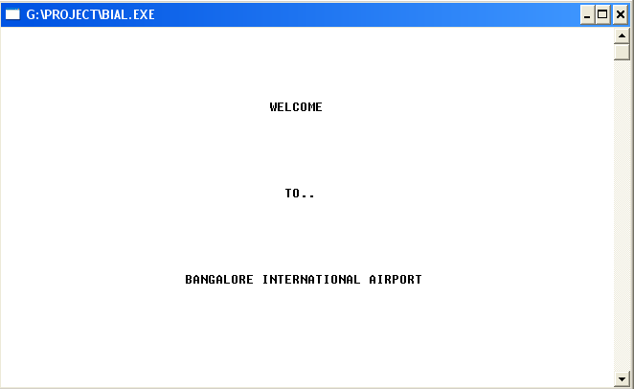

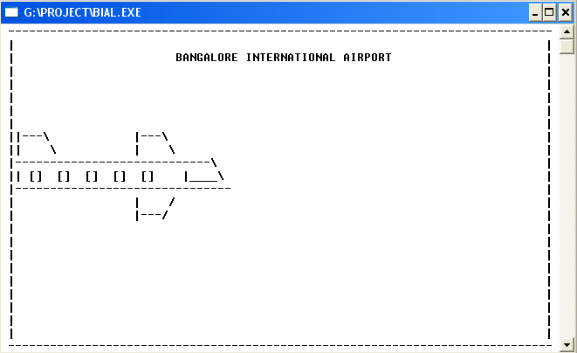
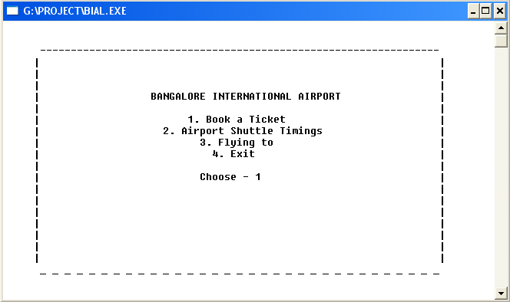

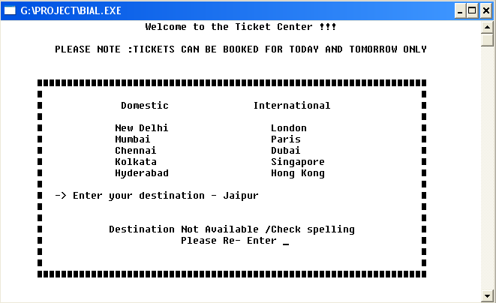
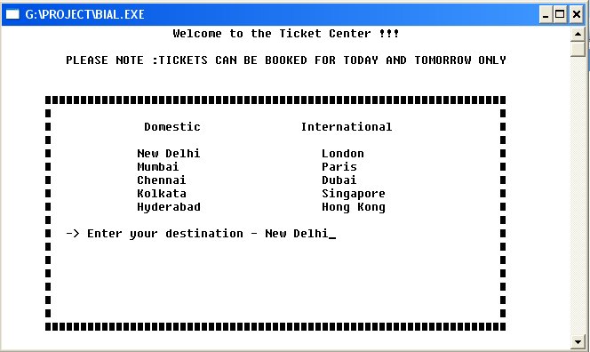

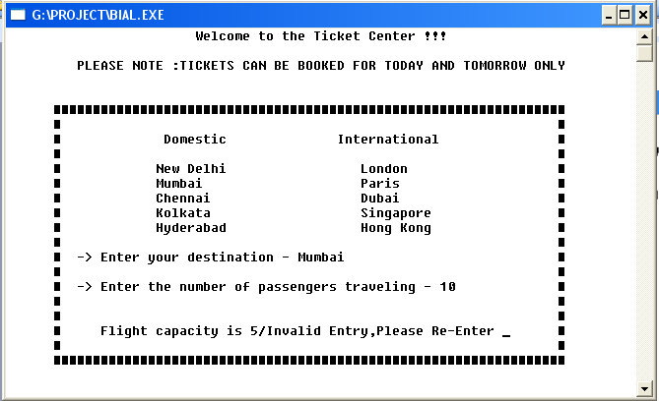
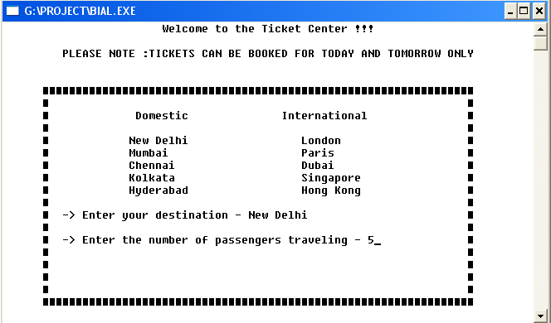

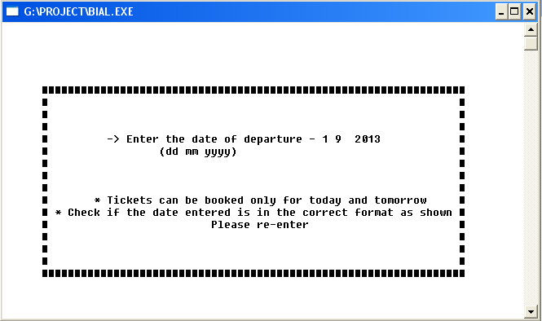

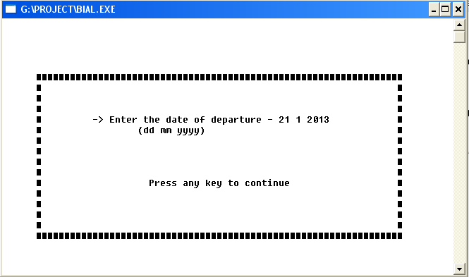

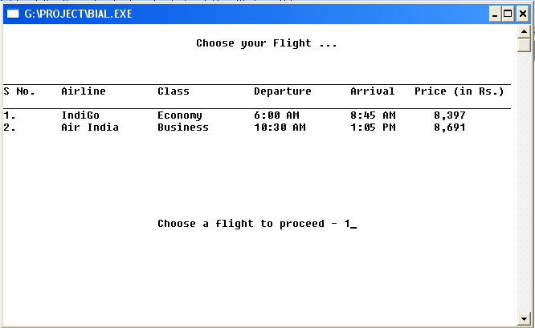

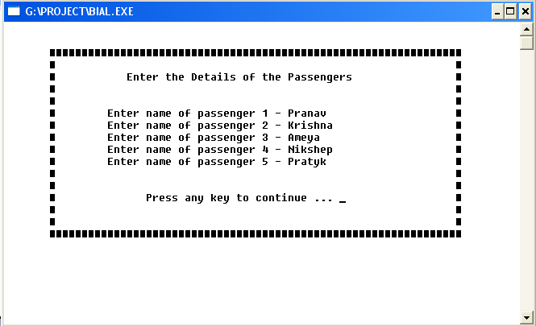

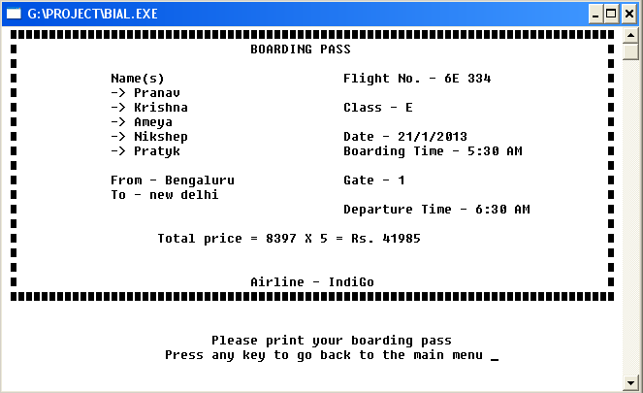

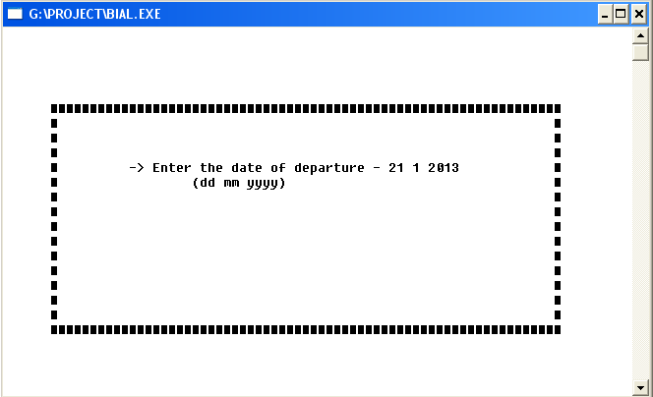

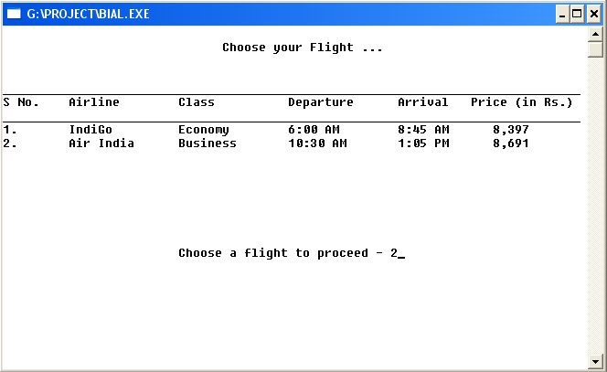

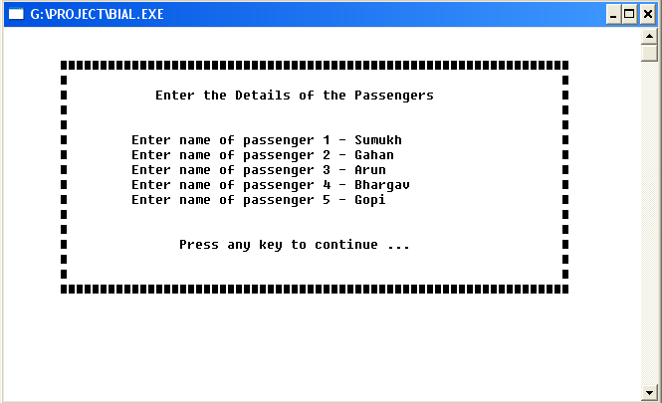

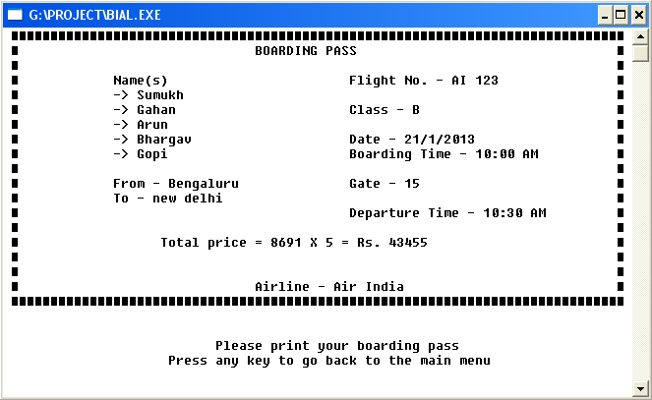

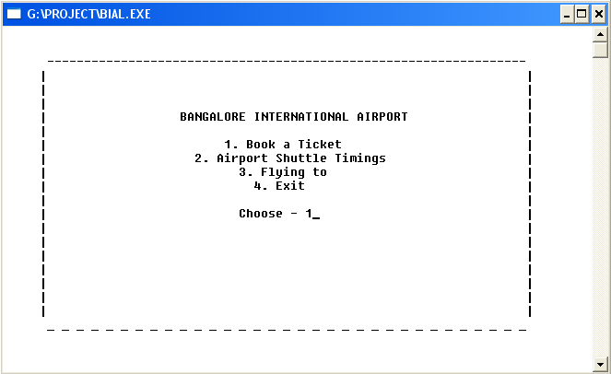

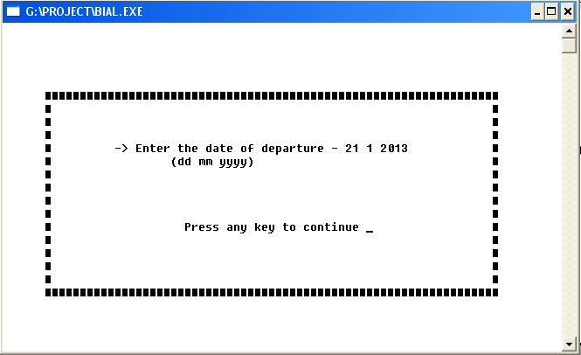

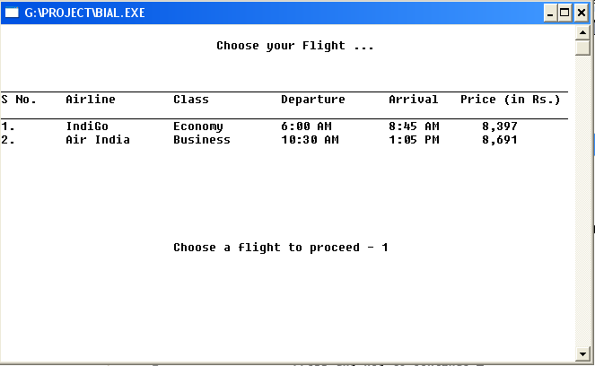

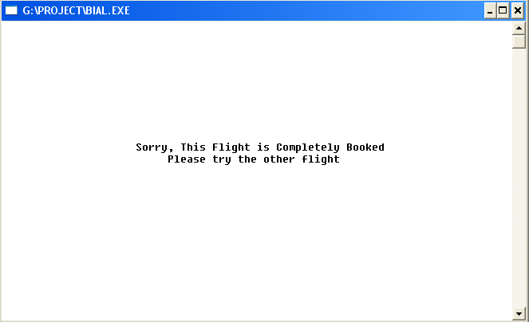

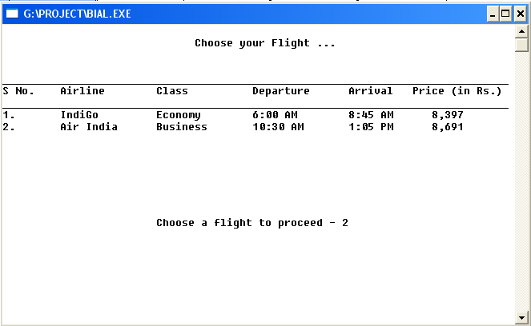

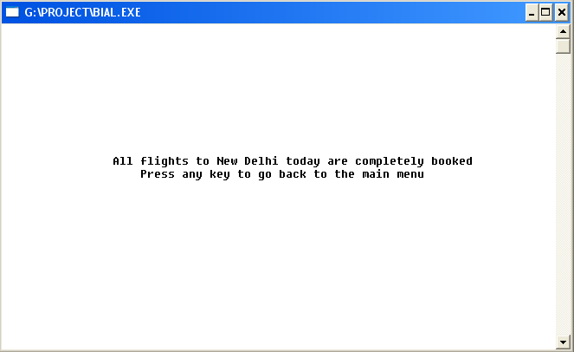

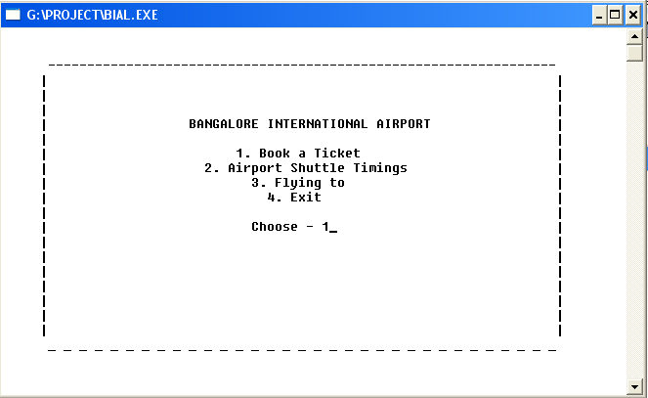

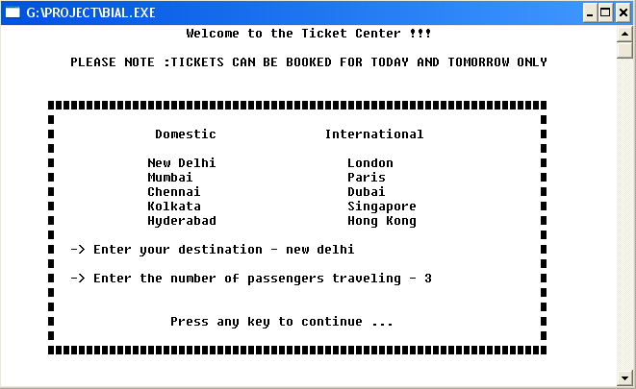

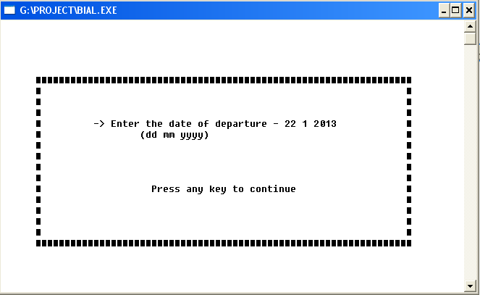

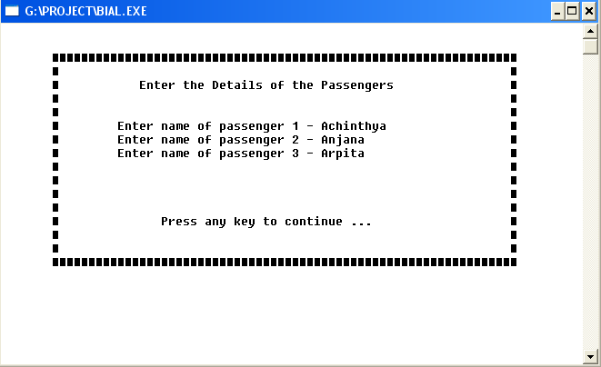

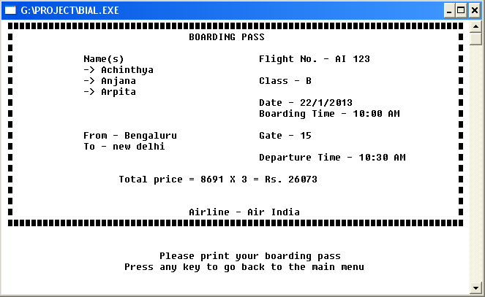

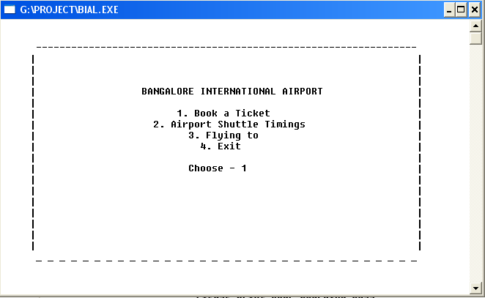

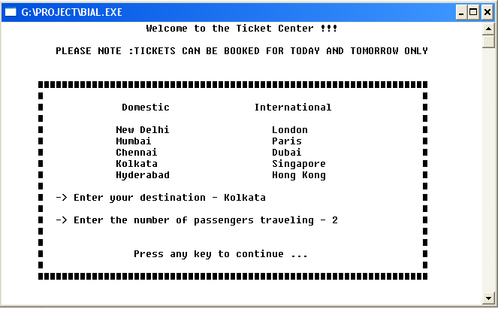

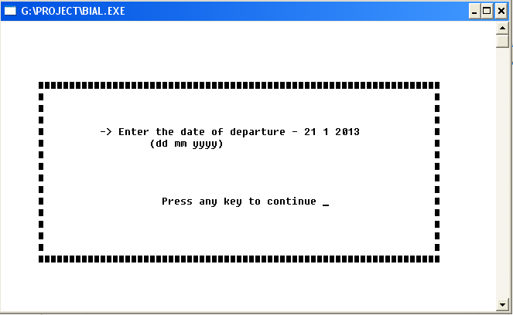

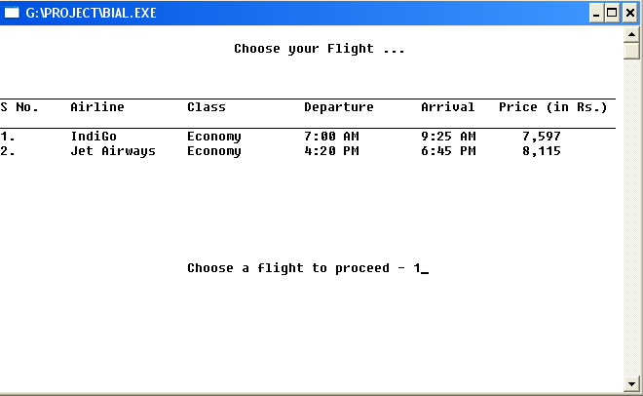

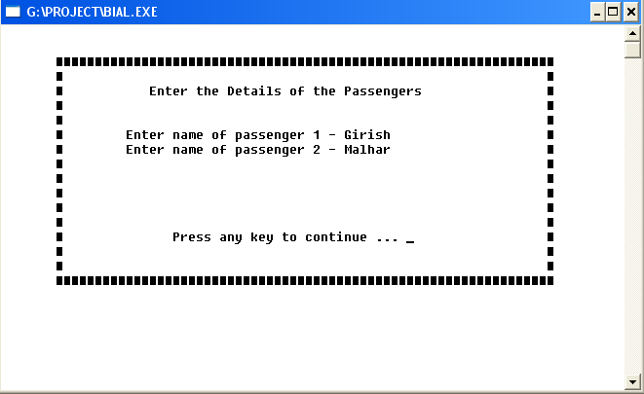

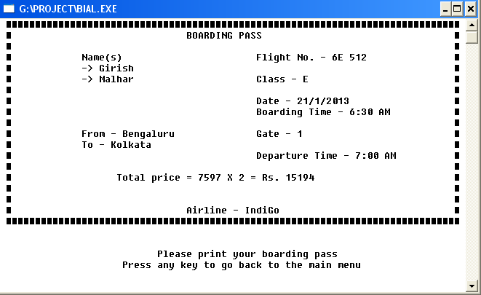

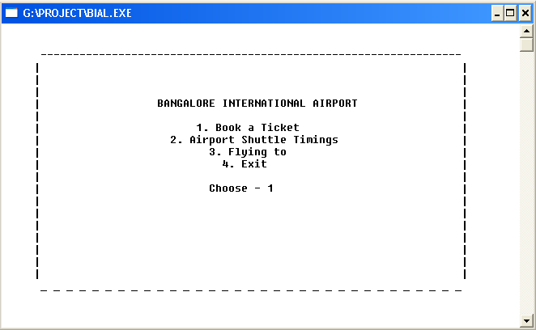

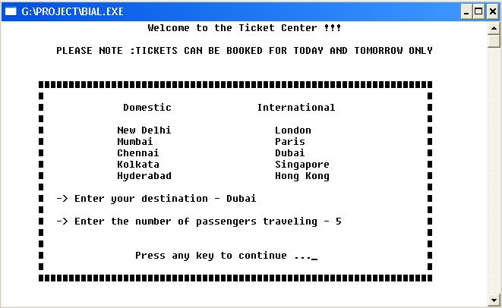

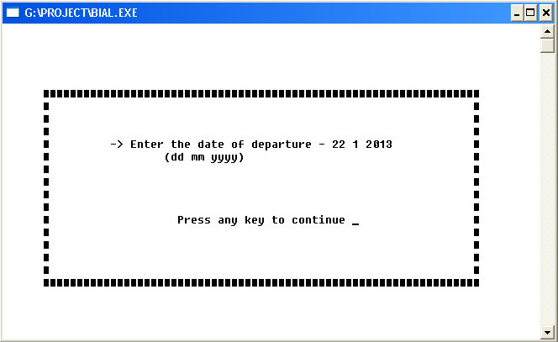

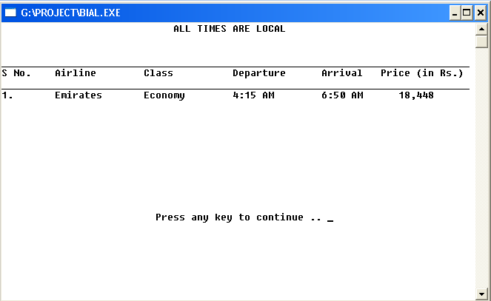

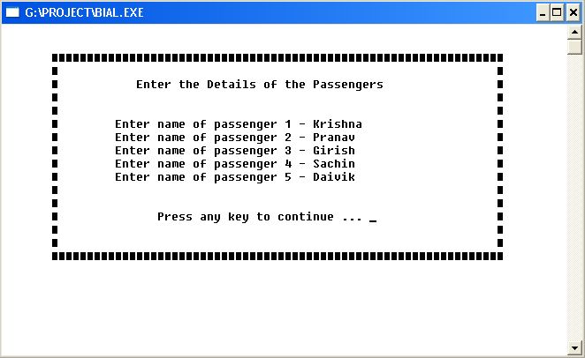

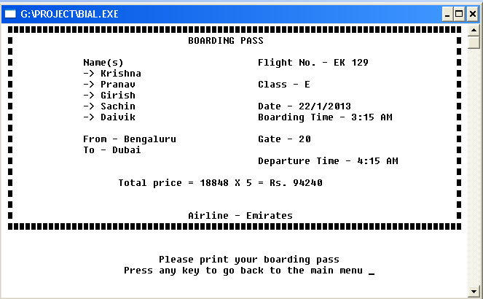

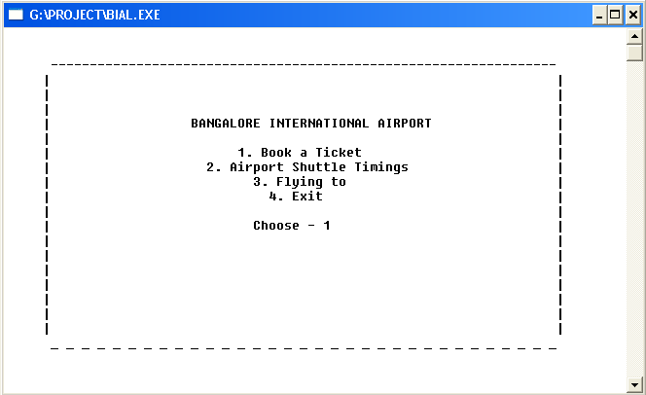

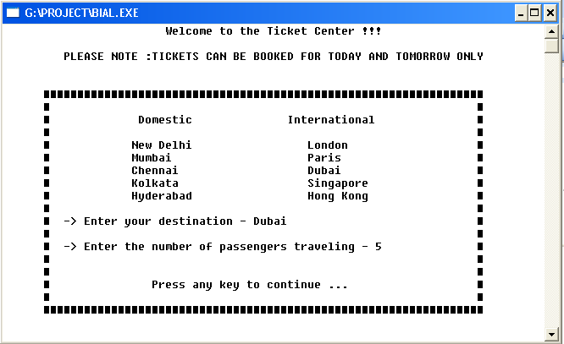

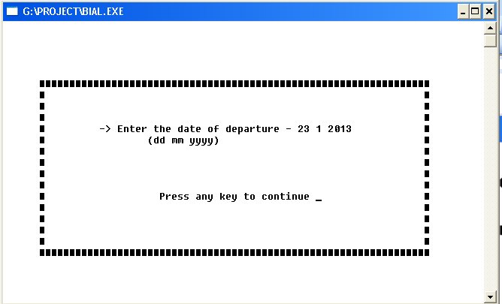

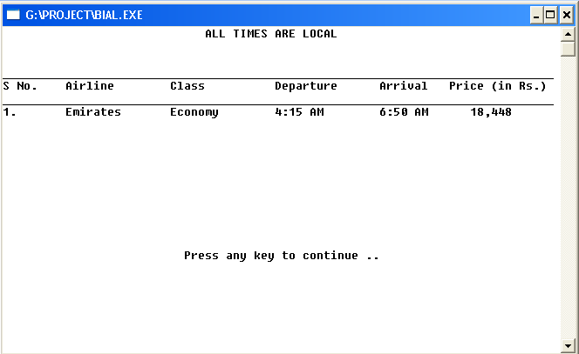

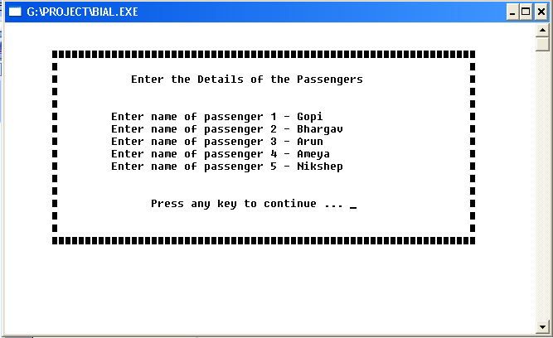

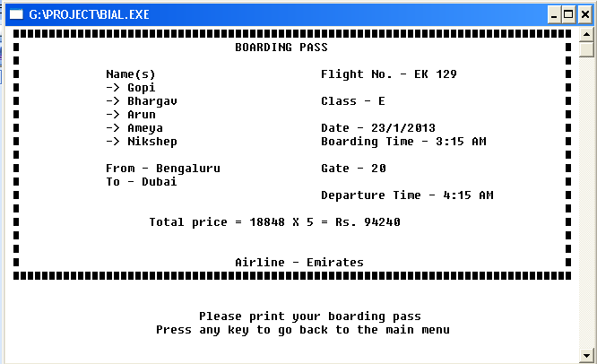

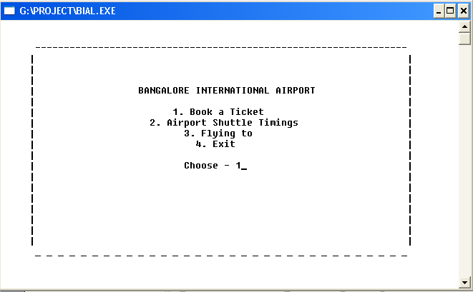

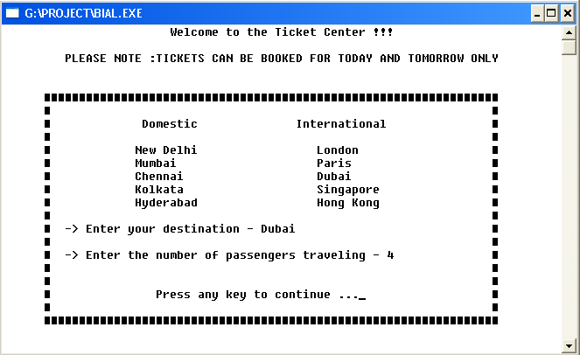

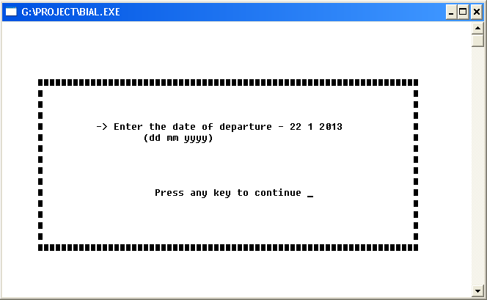

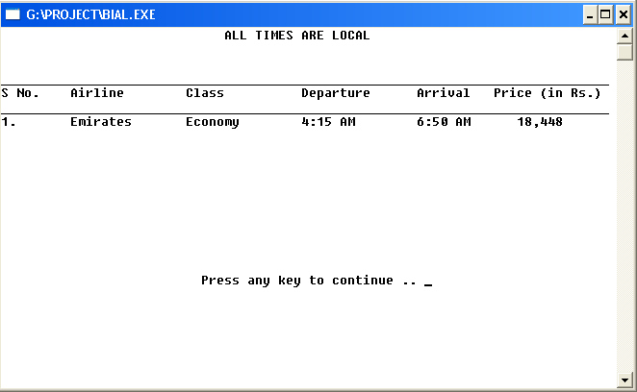

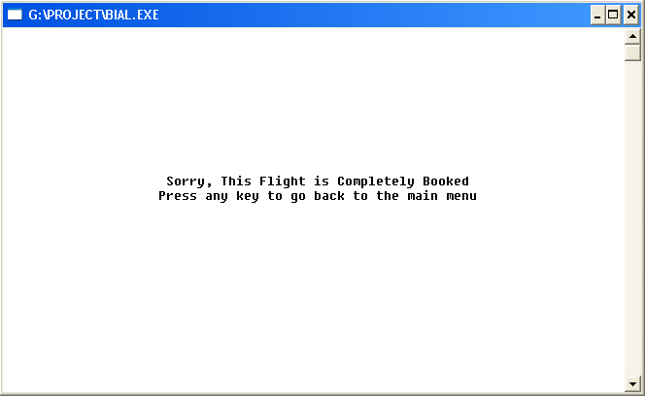

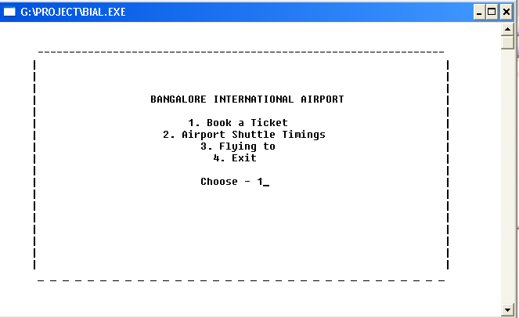

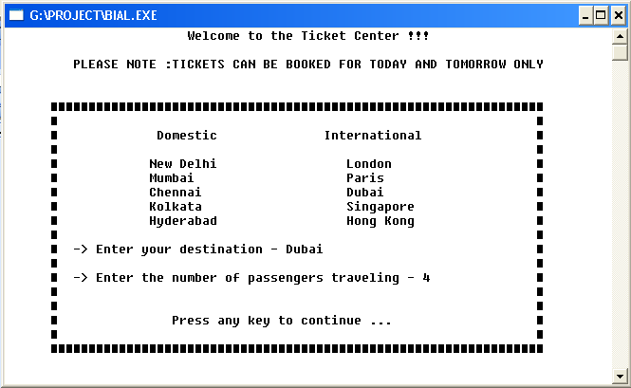

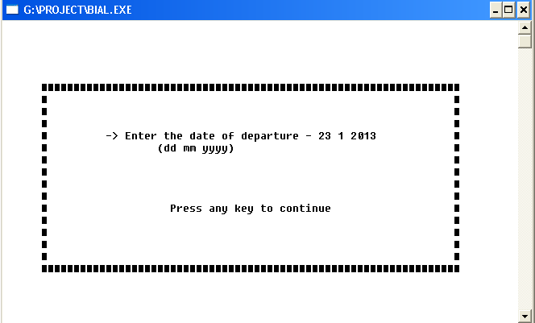

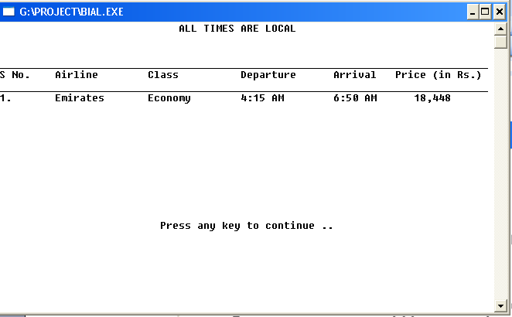

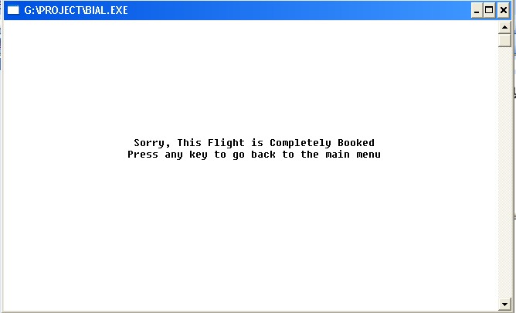

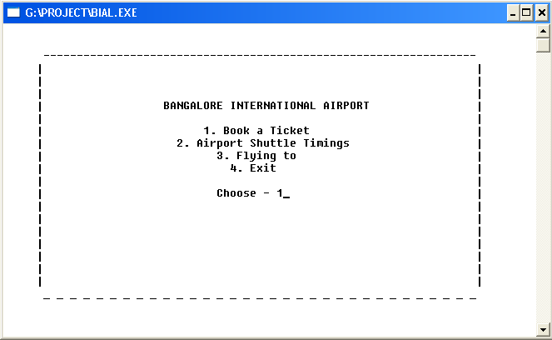

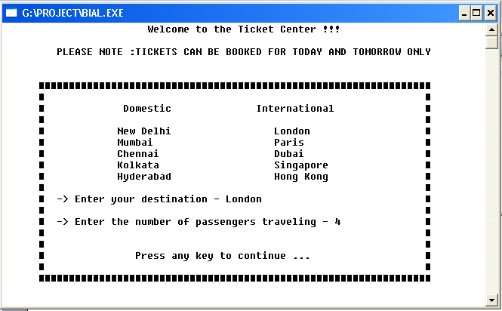

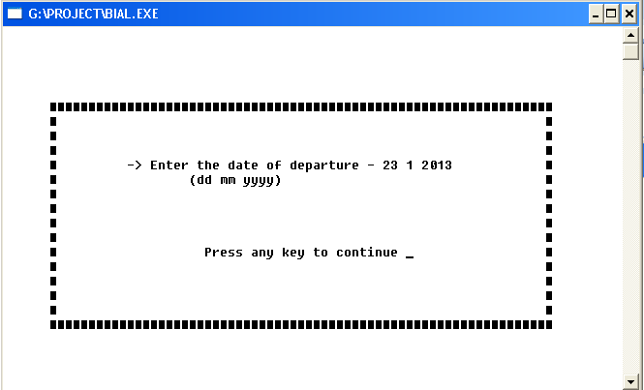

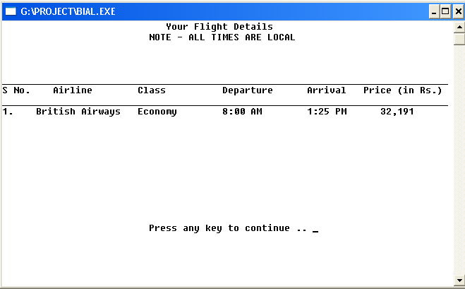

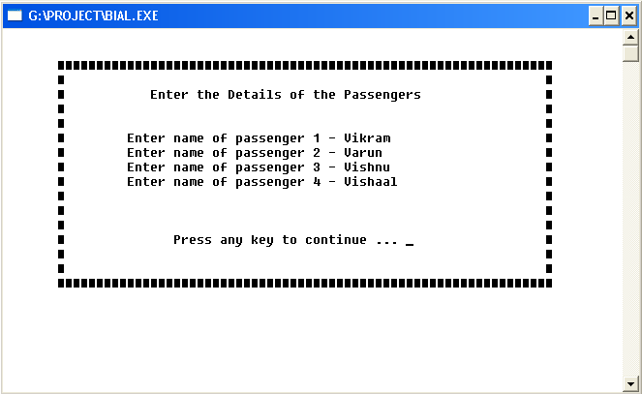

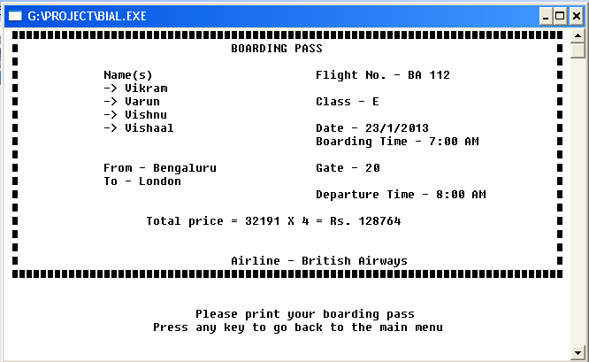

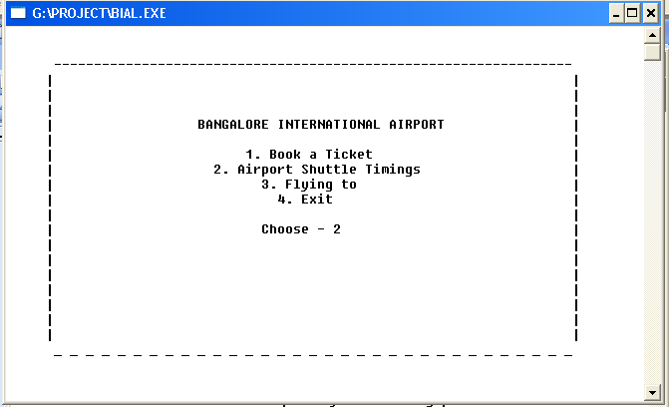

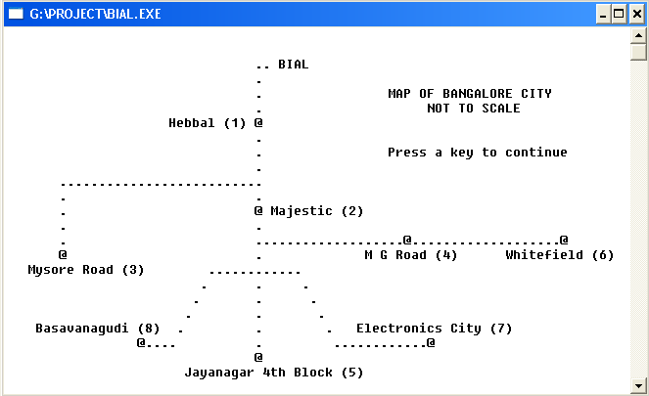

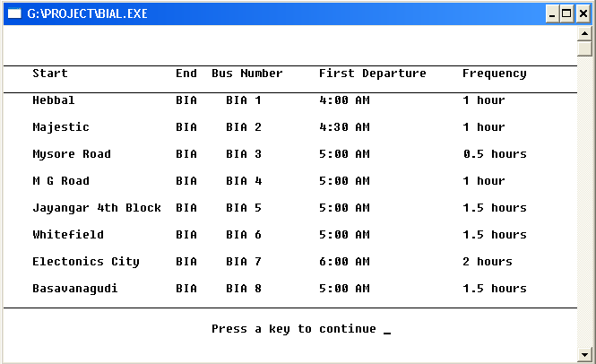

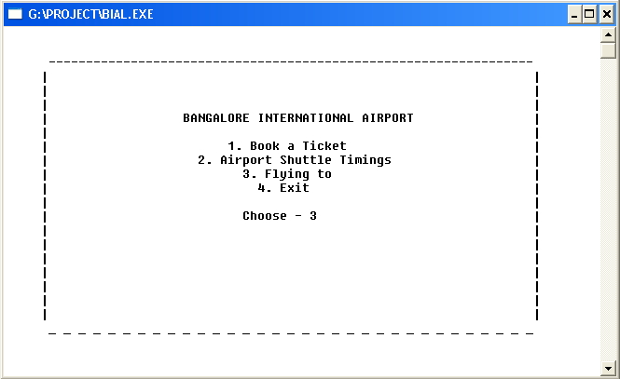

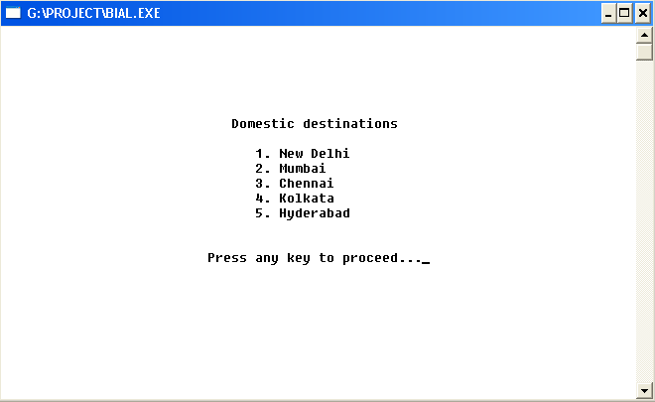

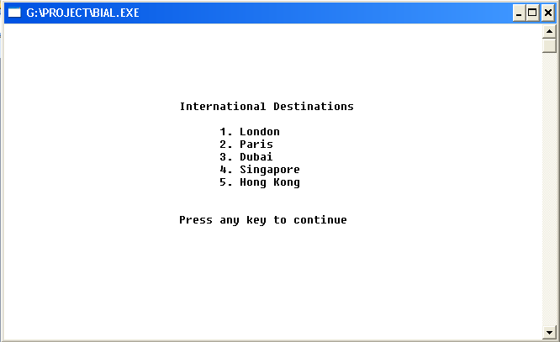

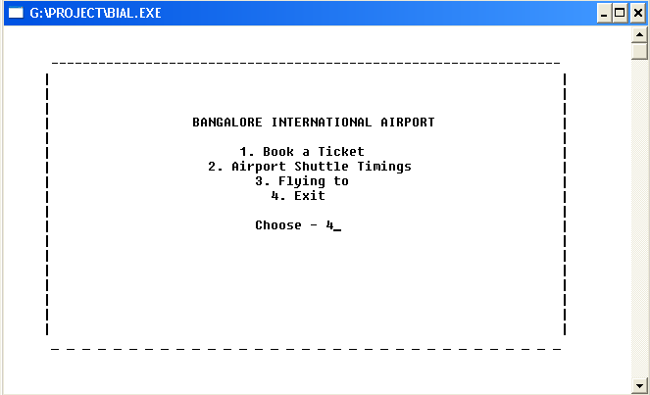

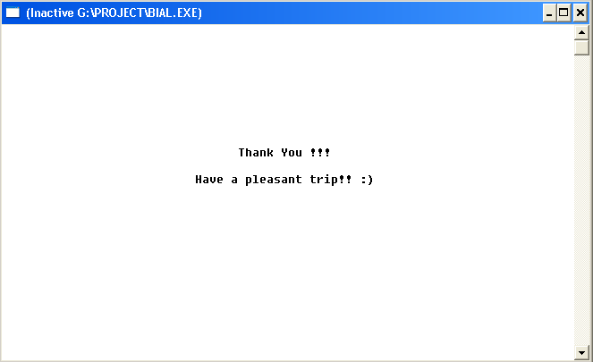

TIME CHART

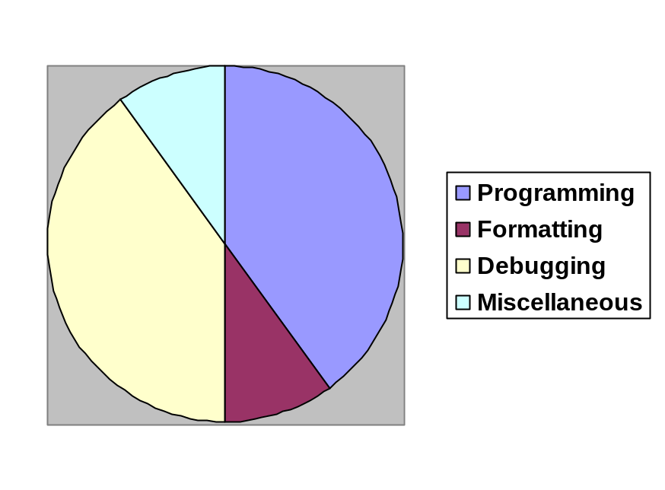

BIBLIOGRAPHY

- Sumita Arora – Concepts of C++ (Class 11 and 12)
- Google

